Question 1

a)
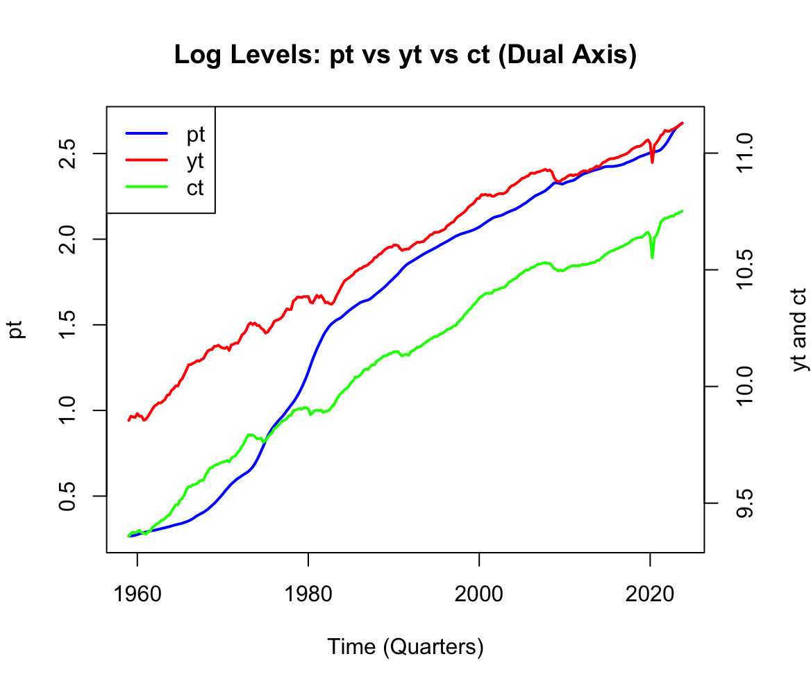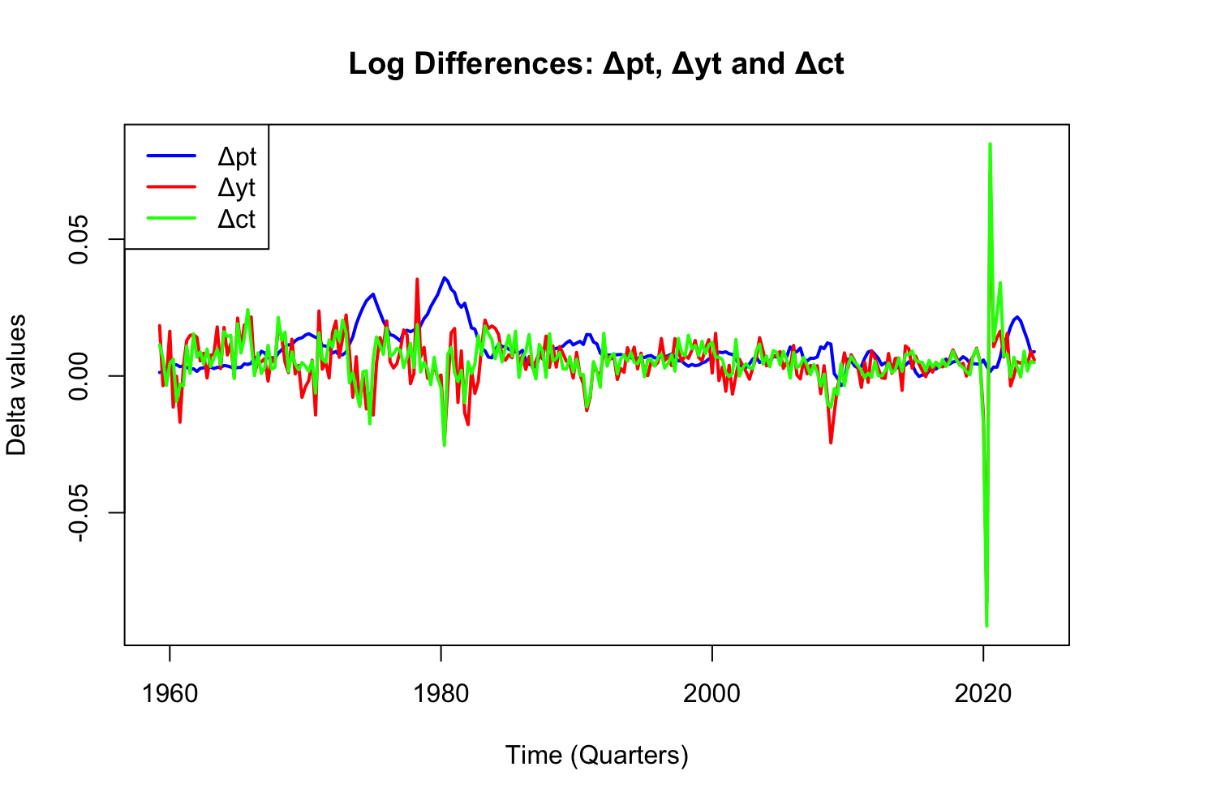
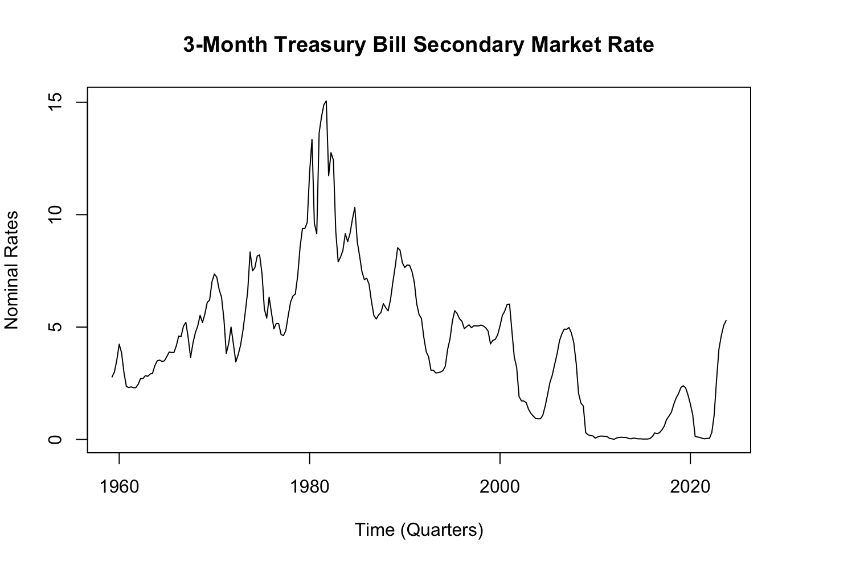
Quarterly time-series of macroeconomic indicators in the USA for the period 1959Q1-2023Q4 (260 observations, where pt is CPI, yt is real GDP, ct is real PCE)
From the log levels of inflation and gdp time series, it is observed that all appear to have a strong upwards trend, non-stationary as the means does not appear to be constant over time as shown between 1959 to 2020.

The first differences depict fluctuations around a constant mean and has maintained constant variance with exceptions to a volatility spike in 2020. Overall, this implies a difference stationary characteristic which is consistent with having a unit root, I(1) processes meaning that the trend is most likely stochastic for pt, ct and yt.

Nominal interest rate depicts no simple deterministic trend for the market rate increases from 1960s to 1980, dropping down close to 0% during the 2000s before rising sharply past 2020. This prolonged period of highs and lows indicates possible structural shifts through different economic periods, such as high interest rates in the 1980s and near-zero rates post-2008 financial crisis. Overall, the series exhibits stochastic behaviour, with movements displaying possible underlying stationary process (constant mean) and strong autocorrelation.

b) i.

Series | Intercept (μ̂) | Time Trend (δ̂) | Model
$$y_{t}$$ | 9.945 | 0.004757 | $$9.945+0.004757t+ϵ_{t}$$
$$c_{t}$$ | 9.429 | 0.005305 | $$9.429+0.005305t+ϵ_{t}$$
$$p_{t}$$ | 0.271 | 0.0101 | $$0.271+0.0101t+ϵ_{t}$$

ii. $μ$: $∆pt= 0.009310287, ∆yt=0.004918979, ∆ct=0.005378509$
iii. The purpose of these estimations is to characterise the underlying growth behaviour of the series and assess the presence of a trend. The estimates of the mean difference $\hat{μ}$ and the time trend coefficient $\hat{δ}$ yielded very similar results: $y_{t}$ (0.475% vs 0.490%), $p_{t}$ (1.01% vs 0.931%,) and $c_{t}$ (0.530% vs 0.537%).
Intuitively, both measures capture the average growth rate in the log-level series. The time trend coefficient reflects how the mean evolves over time, while the mean of the first differences captures the average change in the series. The similarity between these estimates suggests that both approaches are capturing a consistent growth pattern in the data.
Overall, the evidence is consistent with the log-level variables being non-stationary and the first-differenced variables being stationary. However, this comparison alone cannot fully establish whether the trend is stochastic, as this would require formal unit root testing. Nevertheless, differencing the series is appropriate for modelling purposes as it yields a stationary process to which ARMA-type models can be used.
Question 2

the Arima models were first found to be inadequate with initial diagnostics. As a result, the sample size of all models was expanded to focus more on goodness-of-fit, AIC, rather than parsimony and complexity in the BIC.

a)

Rank | Constant | Trend | p | d | q | AIC | BIC | p-value
1 | 0 | 0 | 3 | 0 | 6 | -2682.912 | -2647.343 | 0.0009375
2 | 0 | 0 | 2 | 0 | 10 | -2682.726 | -2636.487 | 0.05141
3 | 0 | 0 | 2 | 0 | 5 | -2681.689 | -2653.234 | 0.00437
4 | 0 | 0 | 2 | 0 | 9 | -2681.685 | -2639.003 | 0.08032
5 | 0 | 0 | 1 | 0 | 10 | -2681.487 | -2638.805 | 0.02661
6 | 0 | 0 | 4 | 0 | 9 | -2681.301 | -2631.506 | 0.1159784
Top three adequate $∆pt$ ARMA model estimations (p >0.05)

Rank | Constant | Trend | p | d | q | AIC | BIC | p-value
1 | 0 | 0 | 8 | 0 | 5 | 480.5071 | 530.3567 | 0.6922
2 | 0 | 0 | 8 | 0 | 6 | 480.9930 | 534.4032 | 0.4919
3 | 0 | 0 | 8 | 0 | 2 | 481.4628 | 520.6303 | 0.194
Top three adequate interest rate ARMA model estimations (p >0.05)

b)
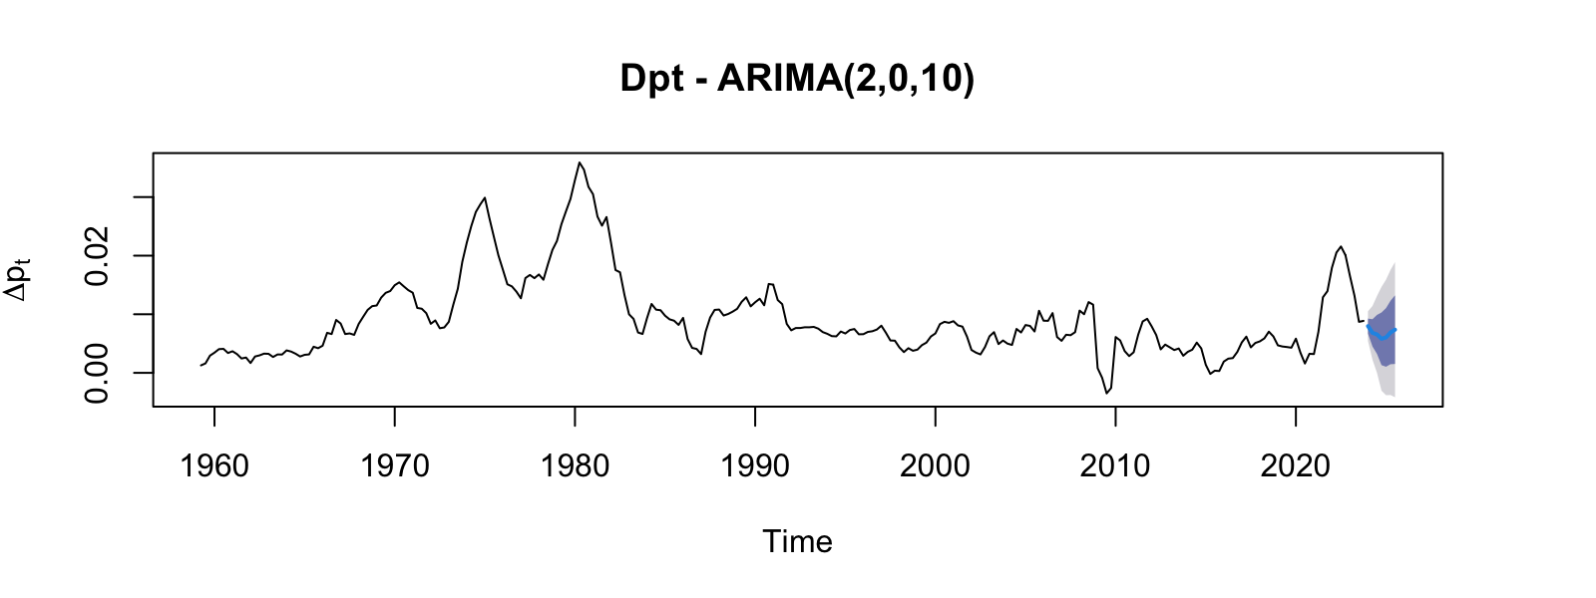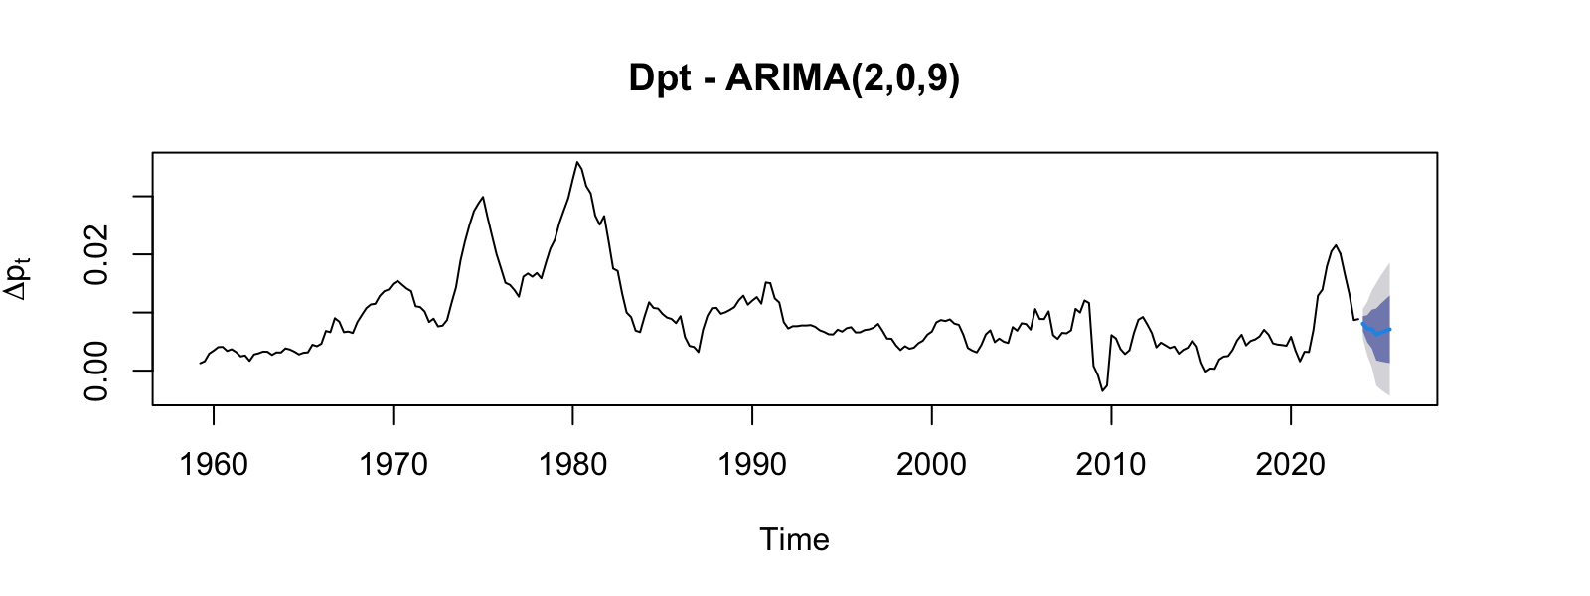
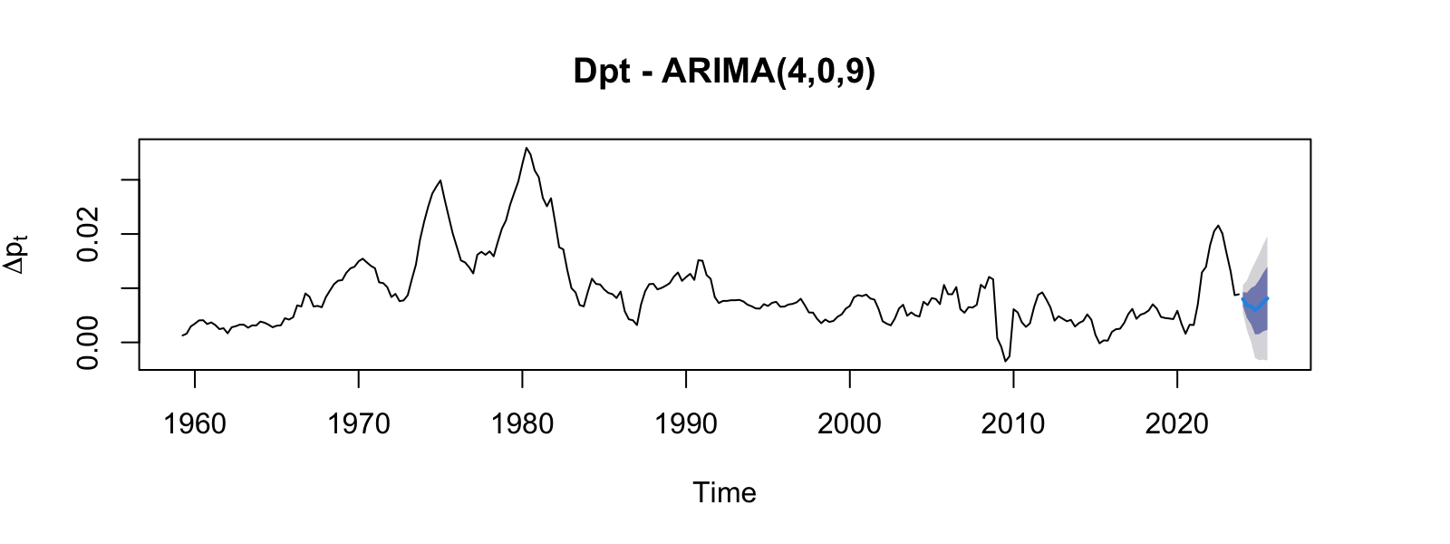
Plot of the $∆pt$ forecasts using ARIMA models
c)

ARIMA forecasts are useful for policy makers as they provide a guidance of potential future economic conditions to make informed decisions on interest rate, fiscal policy, and forward guidance given historical data. This is supported by policy forecasts displaying lowering interest rates to stabilise inflation from 2023.
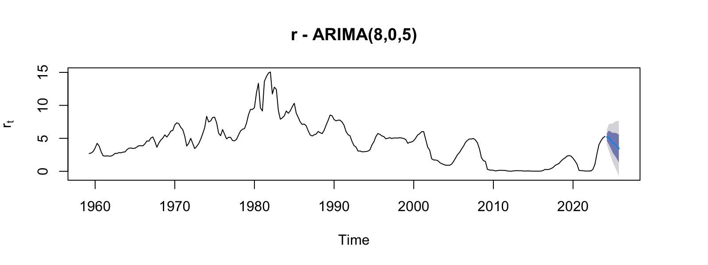
Policy forecast using ARIMA (8,0,5)
There are a few uncertainties to modelling with ARIMA, the first being that the model is based upon estimations of coefficients rather than known with realised data. All three models, (ARIMA (2,0,10) p=0.05, ARIMA (2,0,9) p=0.08 and ARIMA (4,0,9) p= 0.116) show similar forecasts which makes it difficult to determine the true underlying process. ARIMA models do not weigh in the potential of future shocks meaning that realised outcomes may deviate from the forecasts. This ties into the fact that the model assumes constant variance, whereas macroeconomic data often exhibits time-varying volatility. Overall, these uncertainties are reflected in the predictive intervals as the bands (68% and 95%) increases overtime and will be important for model selection.

Question 3
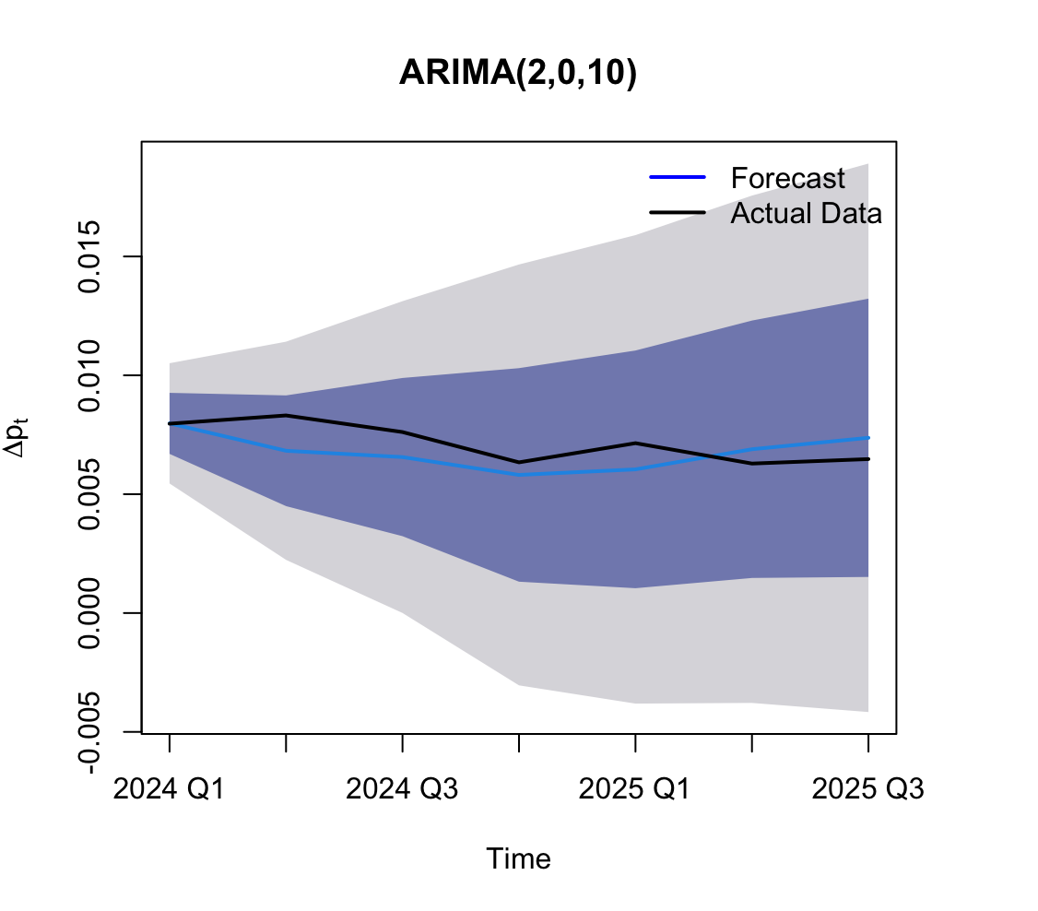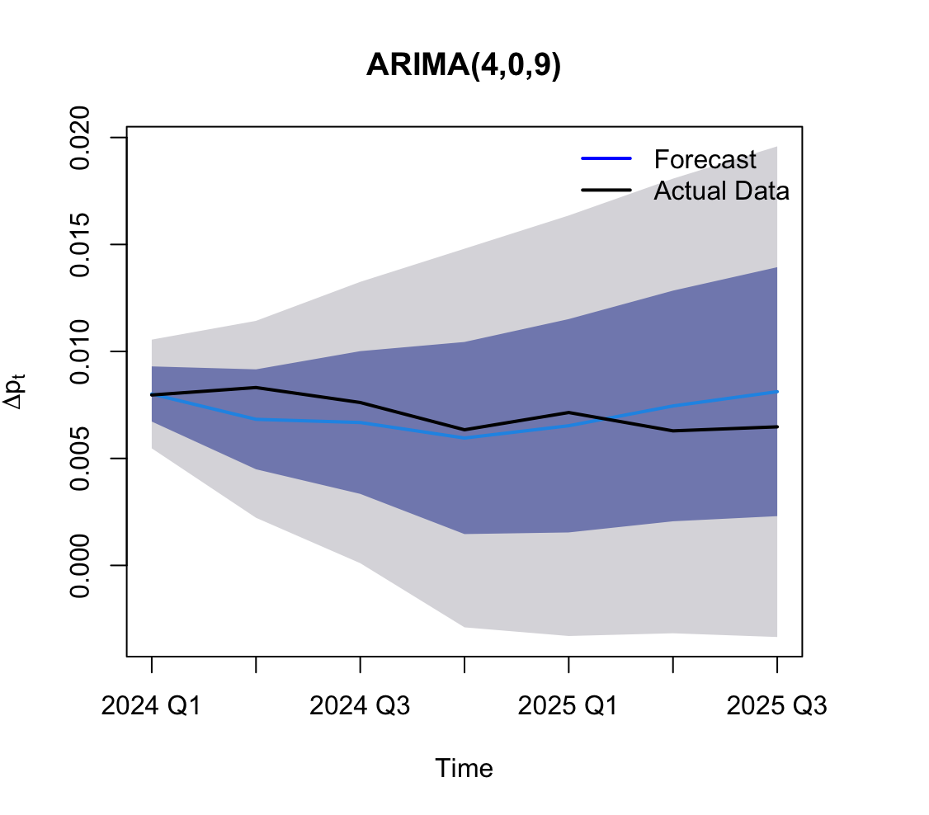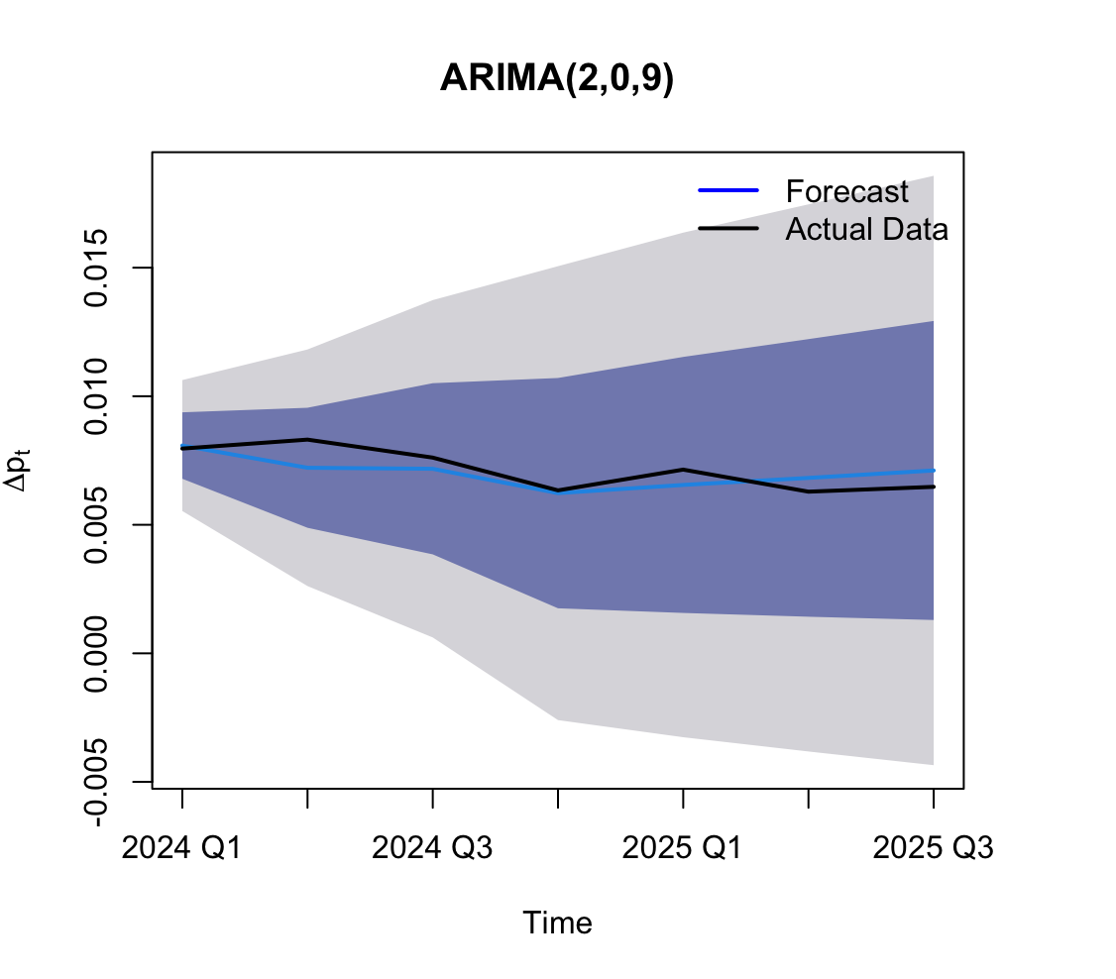
Forecasts of ARIMA model compared to observed CPI returns

ARIMA (2,0,9) appear to have the least amount of forecasting errors as it closely matches the inflationary levels without overfitting to noise. The stochastic series has been relatively stable over the forecast horizon period and is reflected by the predictive intervals which does not appear to shift in a particular direction.

In contrast, ARIMA (4,0,9) and ARIMA (2,0,10) appear to have more variable forecasting where results attempt to capture short-term fluctuation rather than the underlying dynamics. Both models appear to suggest a stronger recovery in the rate of increase post 2024 Q4, causing a slight deviation to the actual inflationary levels.

Nevertheless, the bigger picture suggests that all three models produce similar forecasts in that it puts more emphasis on predicting a steady increase in inflation. Despite relatively high complexity, the selected models do not appear to overfit, as they produce stable and consistent forecasts across specifications with adequate residual testings.

Question 4

a)
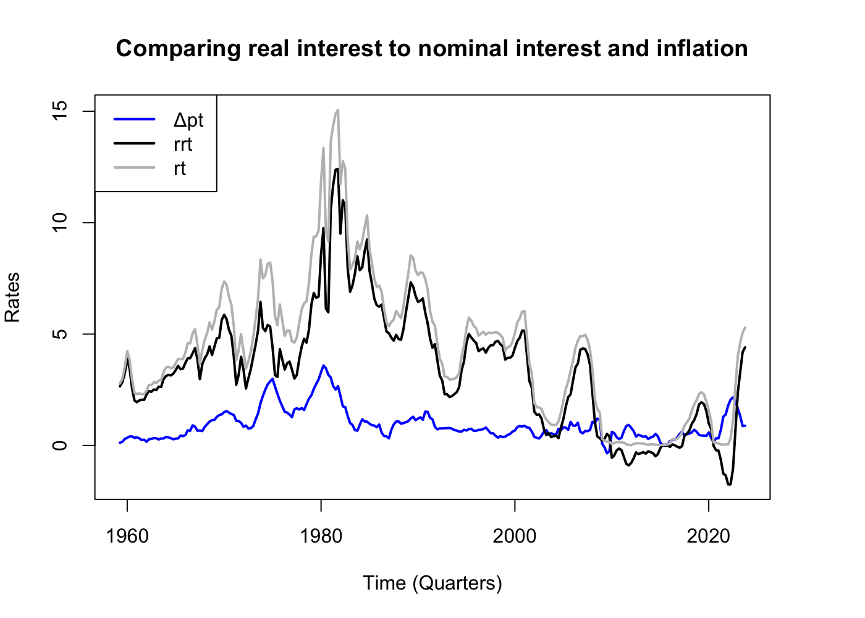
Comparison of real, nominal interest against inflation rate

It is observed that inflation appears more stable than both nominal and real interests, fluctuating within a relatively narrow range (1-3%). Nominal interest rates exhibit large swings overtime, while real interest rates are more stable than nominal as it adjusts for inflation through $rrt=r_{t}-Δp_{t}$, minimising the variability. This greater volatility in interest rates can be attributed to monetary policy responses to economic shocks, whereas inflation is more anchored due to policy targets and expectations. Mechanically, the variability in inflation should also be interpreted with caution, as it is measured as a rate of change – the first difference of price level, appearing more stable relative to level variables like interest rates. Nevertheless, this is necessary, as inflation is represented as $∆p_{t}$ and is the appropriate variable for analysis. In conclusion, real interest rates exhibit moderate stability, and like nominal interest, display a constant mean, indicating an underlying stationary process with strong autocorrelation.

b)
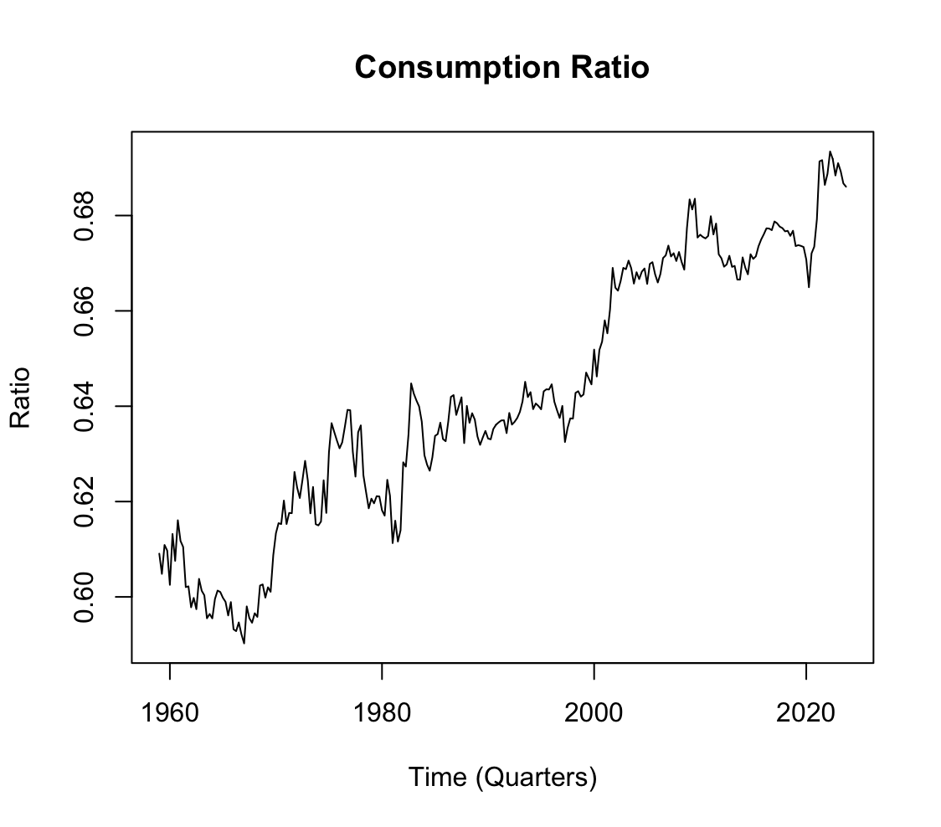
Consumption ratio against GDP

From the 1970s, the consumption ratio appears to have a strong upwards trend with only minor fluctuations. In an economic perspective, shows that consumption has been growing more than output over the same period. This leads to an increased share of GDP to being allocated to consumption. This may be driven by structural factors such as persistent trade deficits. Based on the plot, the mean does not appear to be constant, suggesting series to be non-stationary.
c)

Rank | Const | Trend | p | d | q | AIC | BIC | p-value
1 | 0 | 0 | 8 | 0 | 1 | 466.6378 | 502.2061 | 0.3087
2 | 0 | 0 | 8 | 0 | 2 | 467.8534 | 506.9786 | 0.3917
3 | 0 | 0 | 8 | 0 | 5 | 467.8771 | 517.6727 | 0.8184
Top three ARIMA estimations of real interest rate

ARIMA (8,0,1) (p=0.3087) was deemed the best model despite punishments of complexity as all small sample sized models were inadequate – instead relies more on past values and shocks to fit. A dominant feature consistent with observation from 4a is that d=0, no constant or trend, which suggests that rrt is stationary with stochastic behaviours.

d)
Rank | Const | Trend | p | d | q | AIC | BIC | p-value
1 | 1 | 1 | 3 | 0 | 2 | -2146.133 | -2117.648 | 0.8192
2 | 1 | 1 | 3 | 0 | 1 | -2145.637 | -2120.712 | 0.1877
3 | 1 | 1 | 3 | 0 | 3 | -2144.156 | -2112.110 | 0.6782
Top three ARIMA estimations of consumption ratio

ARIMA (3,0,2) (p-value = 0.8192) was deemed the best model. A dominant feature is that the model estimates a deterministic trend with changing mean over time and suggested short-run, temporary stochastic shocks with d=0. This is consistent with observations in 4b, where the apparent trend is reflecting a structural change, most likely explained by the country’s trade deficit.

e)
The ARIMA models of real interest rate is useful as the model estimates fluctuations around a stable mean, allowing policymakers to assess whether deviations reflect temporary shocks or meaningful changes in economic conditions. This is particularly relevant for monetary policy, as central banks can evaluate whether nominal interest rates movements are required.
The consumption ratio exhibits a deterministic trend with d=0, indicating changing long-run structure with temporary shocks. This provides insight into aggregate demand relative to GDP, which is needed for decision in fiscal policies and evaluations of economic resilience.

Question 5.
- $σ_{CNY}^{2}=0.3368546 σ_{USD}^{2}=0.4380863 σ_{TWI}^{2}=0.2674710 σ_{SDR}^{2}=0.4491718$
The unconditional variances show TWI with lowest value of 0.267 suggesting that it is the least volatile out of the series. CNY with 0.337 appears to be intermediate while USD and SDR have the highest, subsequently reflecting its volatility. These estimates are informative about overall dispersion of each stochastic process, however, this does not imply that returns are independently and identically distributed with constant variance. As a result, the results do not largely summarise the volatility of the processes and is insufficient for short-run horizon risk management.

b)
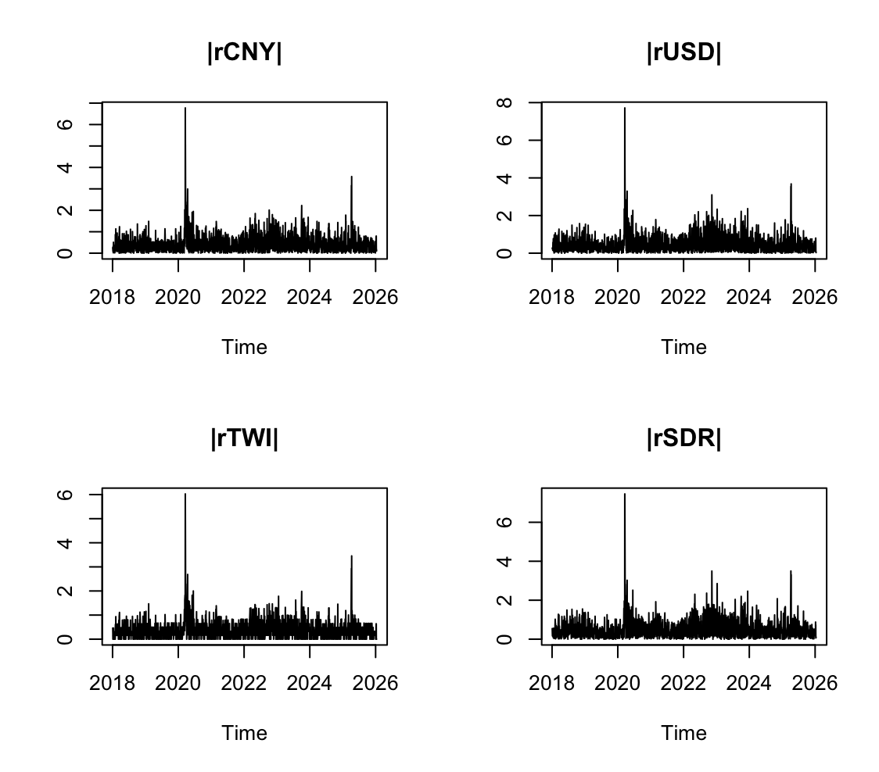
Plot of absolute value of return
The plot of returns appears to depict an absence of independence and identical distribution (iid) where clear volatility clusters are observed from 2018 to 2019 and 2021 to 2024. This persistence shows that large shocks are followed by large shocks and vice versa with small shocks. This is inconsistent with a process that is iid and constant variance but instead suggests potential heteroskedasticity which meant that the exchange rates too is also heteroskedastic. Mean appears to be constant.

Question 6

EX rate return | ARIMA | AIC | BIC | p-value
rCNY | (2,0,3) | 3521.984 | 3561.243 | 0.08175
rUSD | (1,0,0) | 4054.693 | 4071.518 | 0.1636
rTWI | (1,0,3) | 3041.905 | 3075.555 | 0.05486
rSDR | (2,0,3) | 4006.992 | 4046.250 | 0.2141
ARMA model estimations
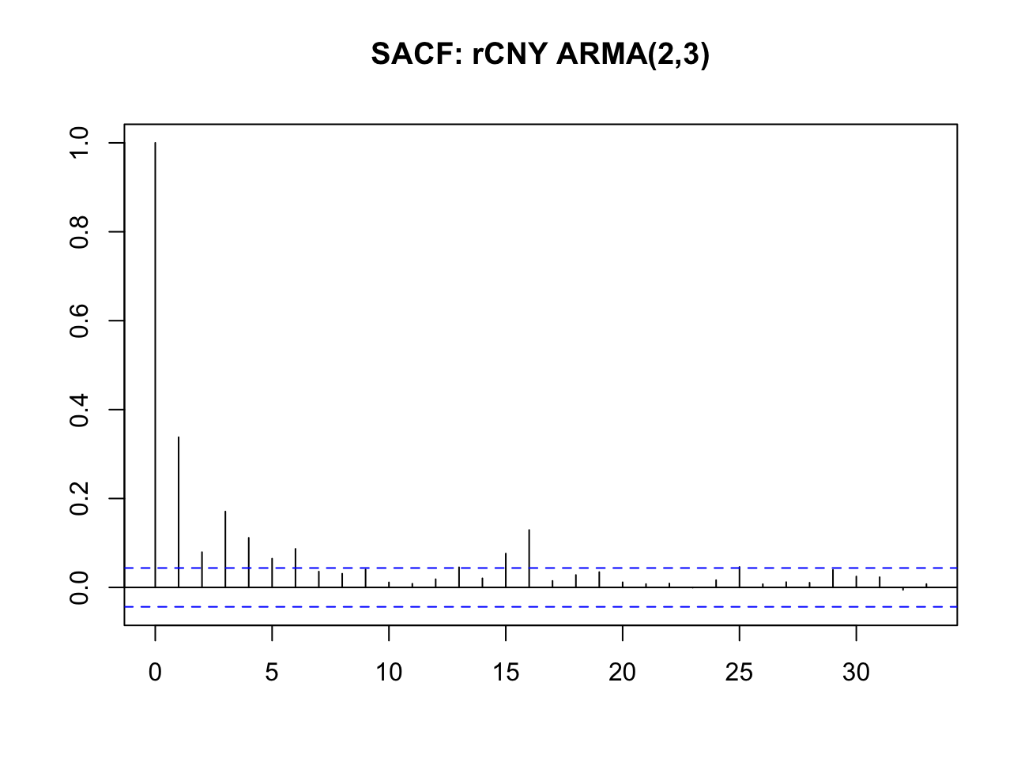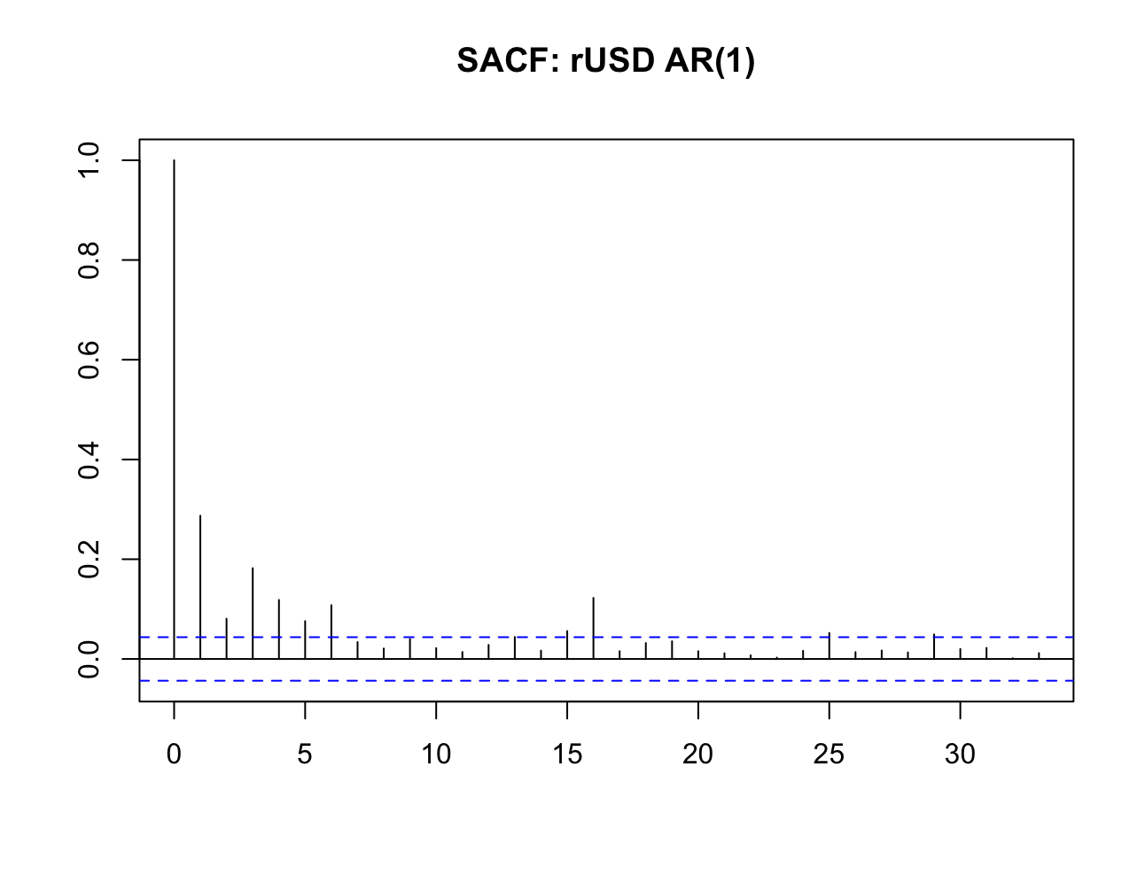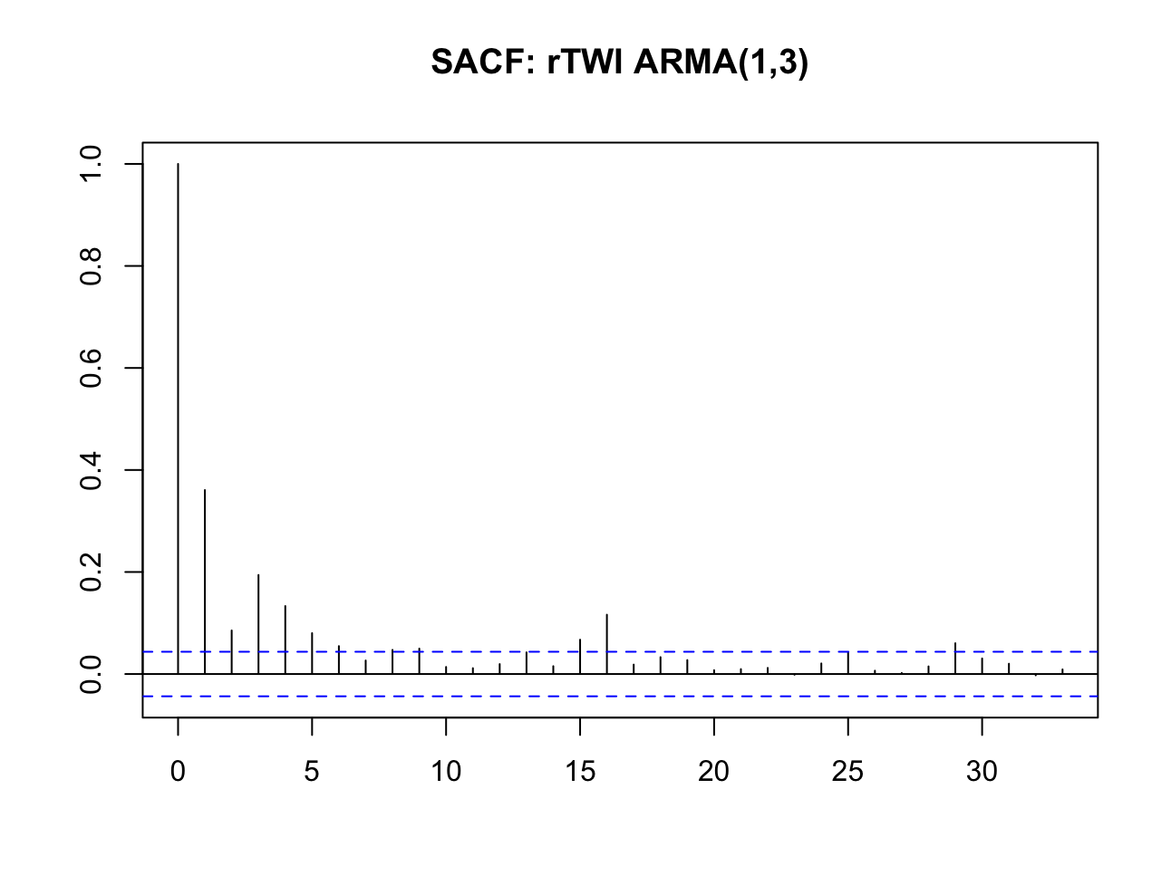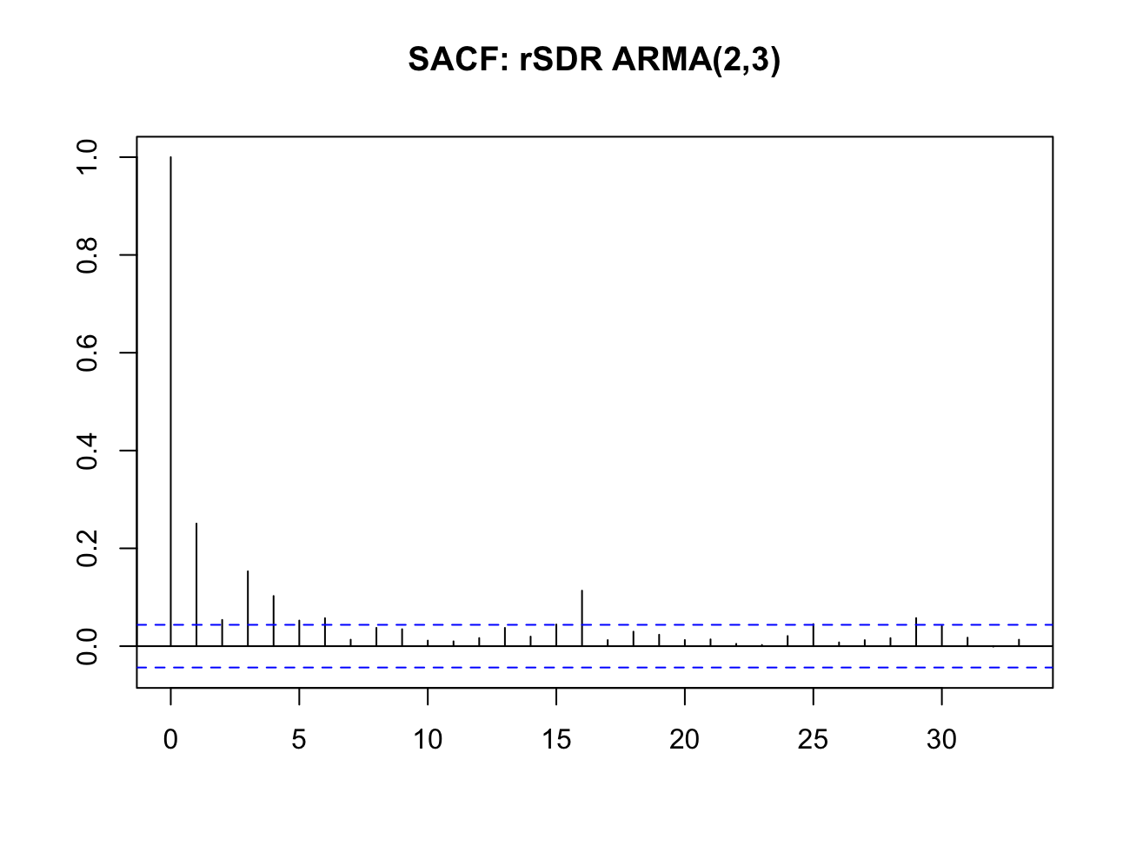
Squared Residual ACF tests
Series | Statistic | 1 | 2 | 3 | 4 | 5 | 6 | 7 | 8 | 9 | 10
CNY | LM Stat | 229.93 | 232.54 | 287.84 | 287.67 | 289.42 | 292.06 | 292.99 | 293.64 | 293.49 | 293.54
 | p-value | <2.22e-16 | <2.22e-16 | <2.22e-16 | <2.22e-16 | <2.22e-16 | <2.22e-16 | <2.22e-16 | <2.22e-16 | <2.22e-16 | <2.22e-16
USD | LM Stat | 166.18 | 166.09 | 221.74 | 222.52 | 224.62 | 230.39 | 232.58 | 232.50 | 232.47 | 232.36
 | p-value | <2.22e-16 | <2.22e-16 | <2.22e-16 | <2.22e-16 | <2.22e-16 | <2.22e-16 | <2.22e-16 | <2.22e-16 | <2.22e-16 | <2.22e-16
TWI | LM Stat | 262.01 | 266.49 | 341.75 | 341.66 | 345.00 | 345.30 | 345.21 | 346.46 | 346.62 | 346.64
 | p-value | <2.22e-16 | <2.22e-16 | <2.22e-16 | <2.22e-16 | <2.22e-16 | <2.22e-16 | <2.22e-16 | <2.22e-16 | <2.22e-16 | <2.22e-16
SDR | LM Stat | 126.65 | 126.76 | 169.98 | 171.62 | 172.26 | 173.08 | 174.17 | 175.95 | 175.88 | 175.77
 | p-value | <2.22e-16 | <2.22e-16 | <2.22e-16 | <2.22e-16 | <2.22e-16 | <2.22e-16 | <2.22e-16 | <2.22e-16 | <2.22e-16 | <2.22e-16
Breusch–Pagan Lagrange Multiplier (LM) test

Squared residuals all show autocorrelations from lags 1-5, volatilities are correlated – potential ARCH affects. Furthermore, all Breusch–Pagan Lagrange Multiplier (LM) test provided very strong evidence of heteroskedascity with p values close to 0, rejecting the null hypothesis and that the ARMA model were mispecified. Hence there is ARCH-effect which will be modelled using ARMA-GARCH.

EX rate return | $$ARMA\left(p, q\right)-GARCH(pσ, qσ)$$ | AIC | BIC
rCNY | ARMA (2,2)-GARCH (2,1) | 1.551433 | 1.576483
rUSD | ARMA (2,2)-GARCH (2,2) | 1.834596 | 1.862429
rTWI | ARMA (2,2)-GARCH (2,2) | 1.310895 | 1.338729
rSDR | ARMA (2,2)-GARCH (2,1) | 1.821043 | 1.846093
ARMA-GARCH model estimations
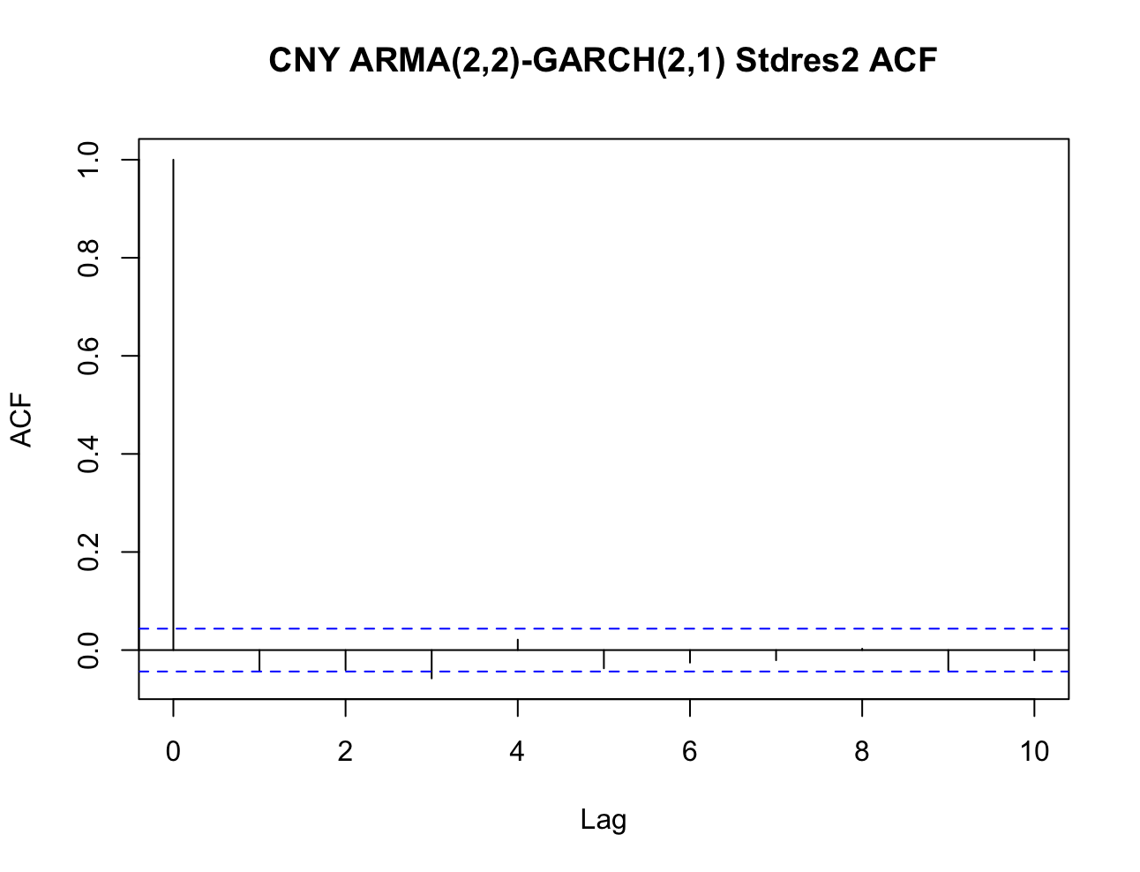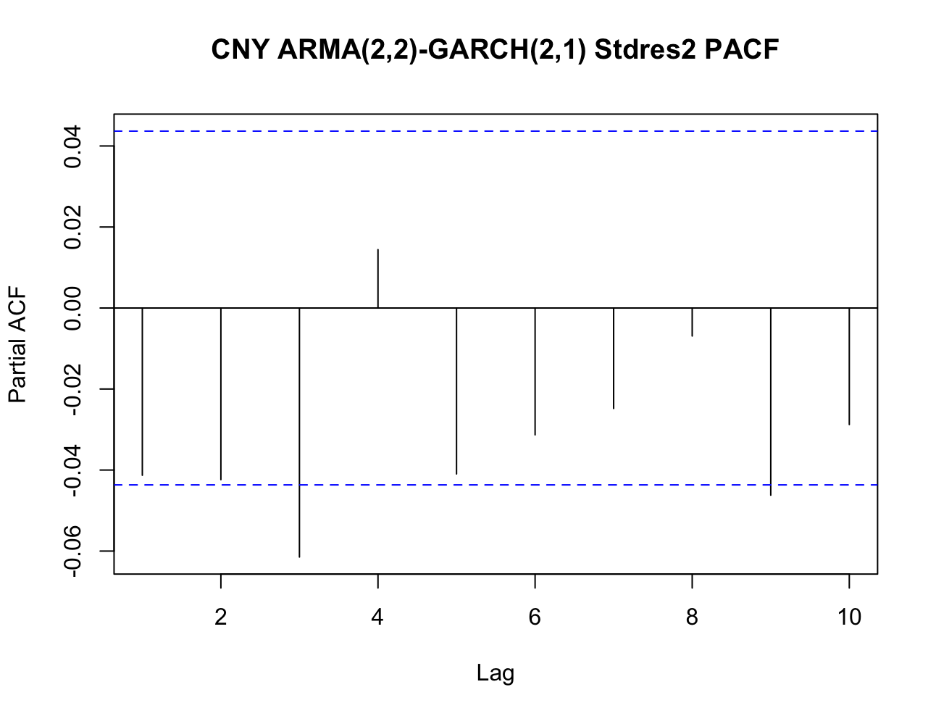
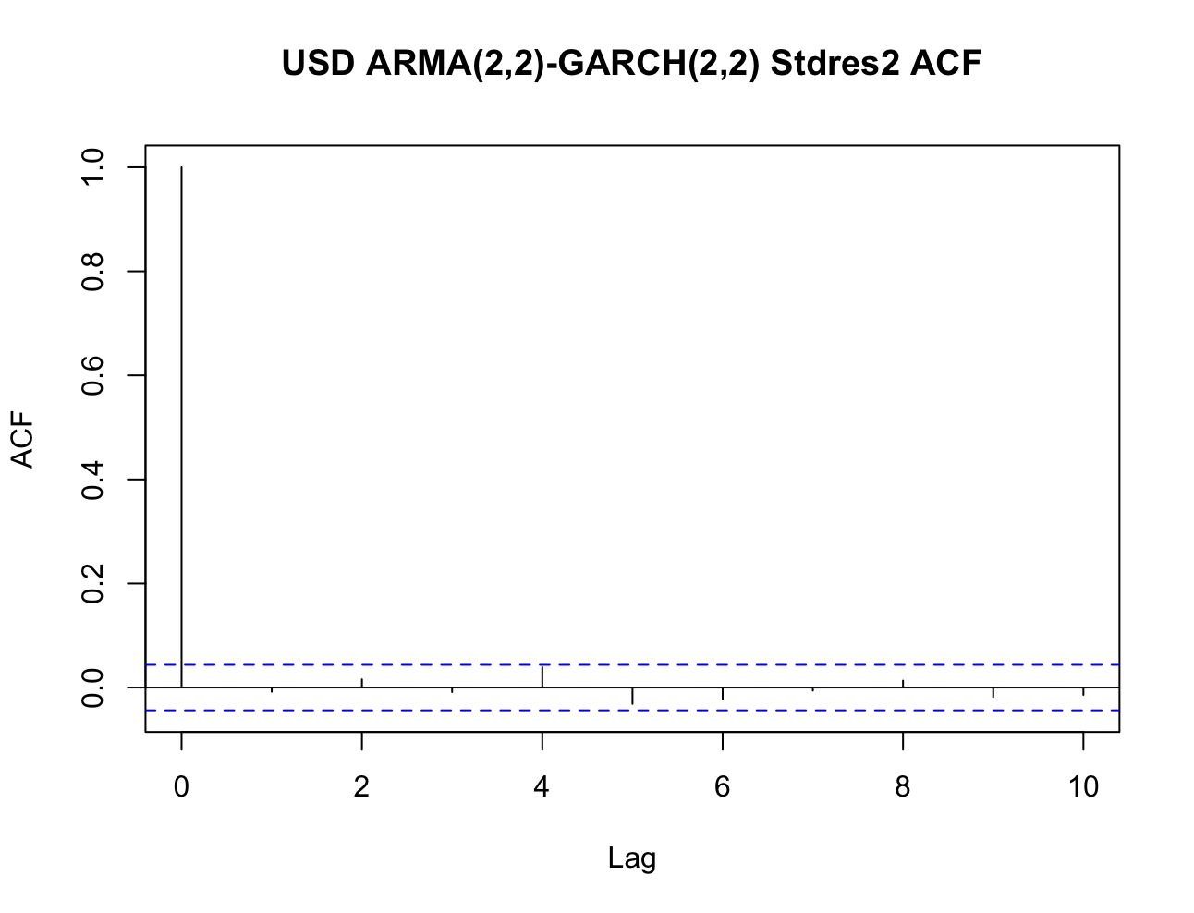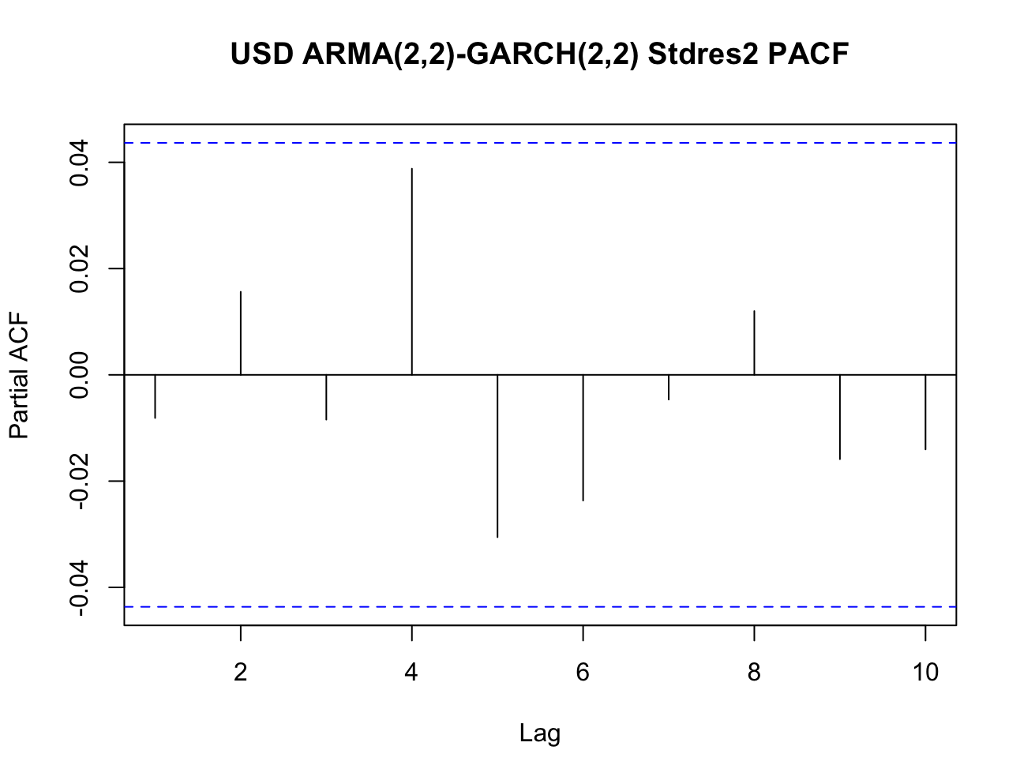
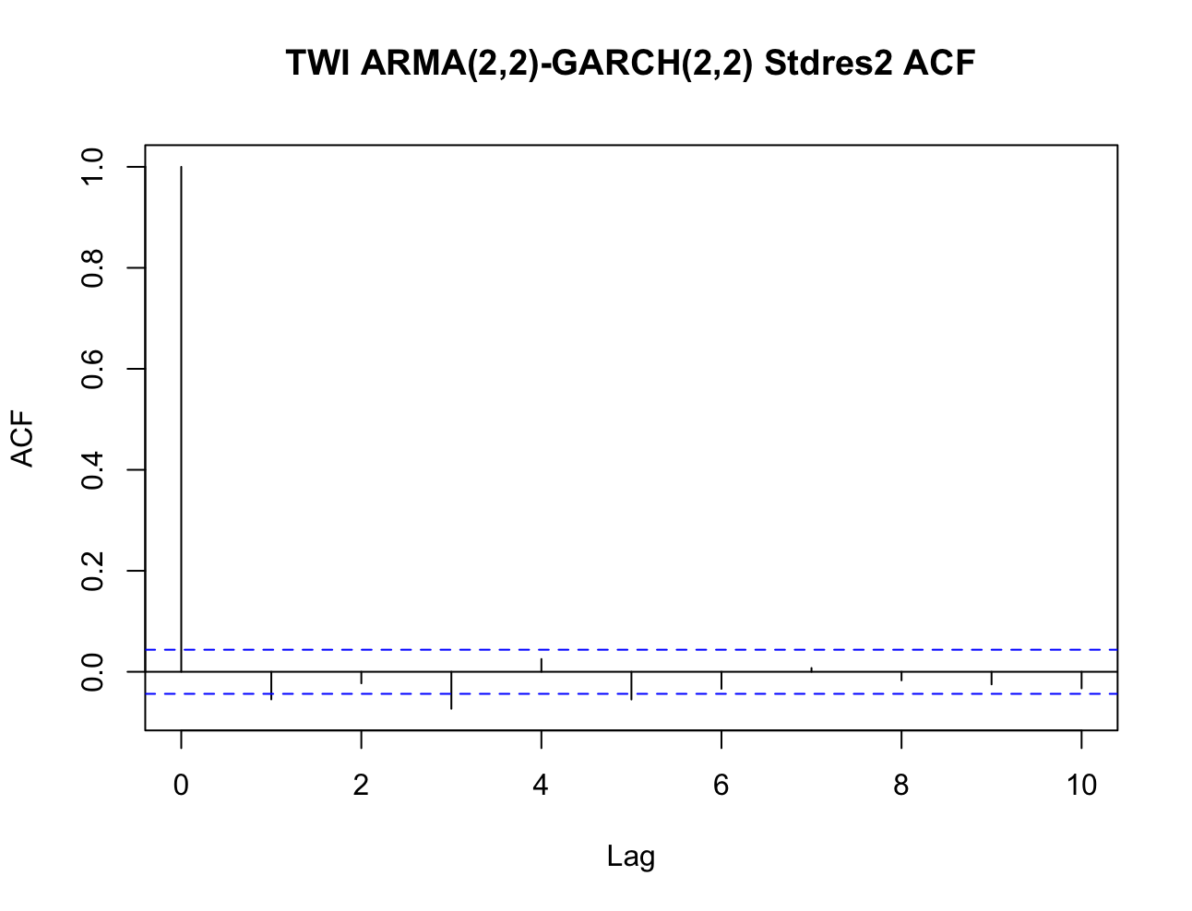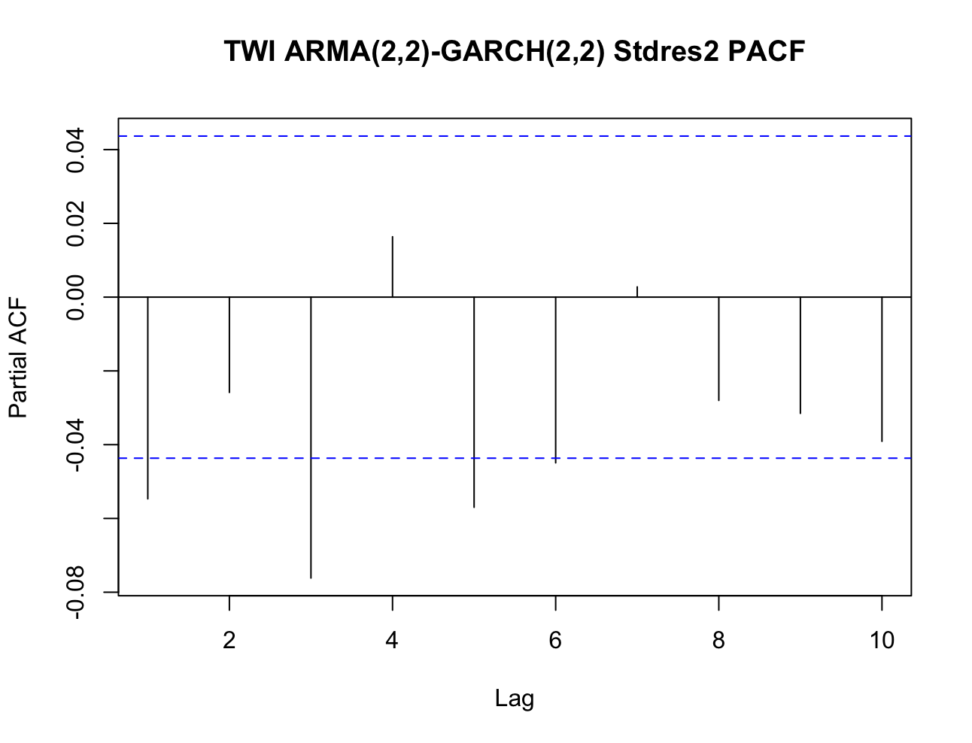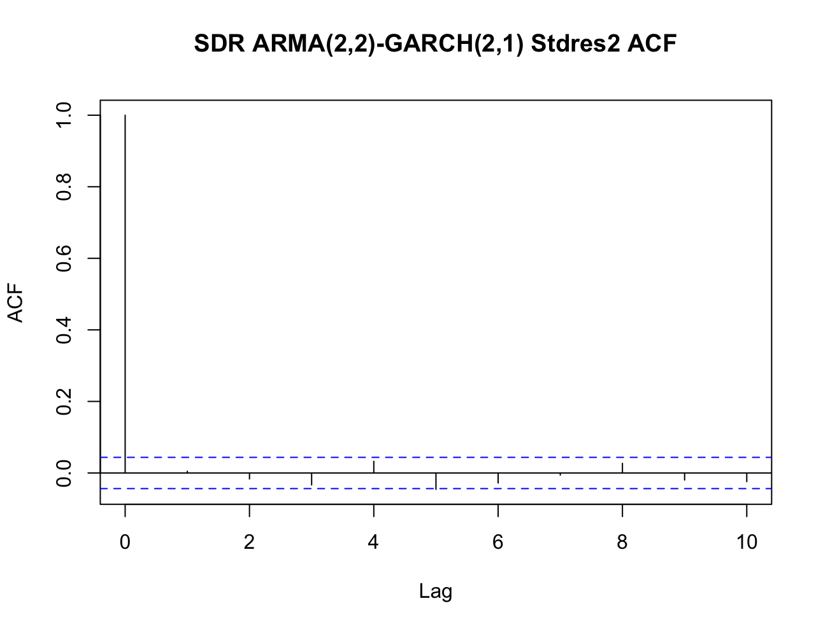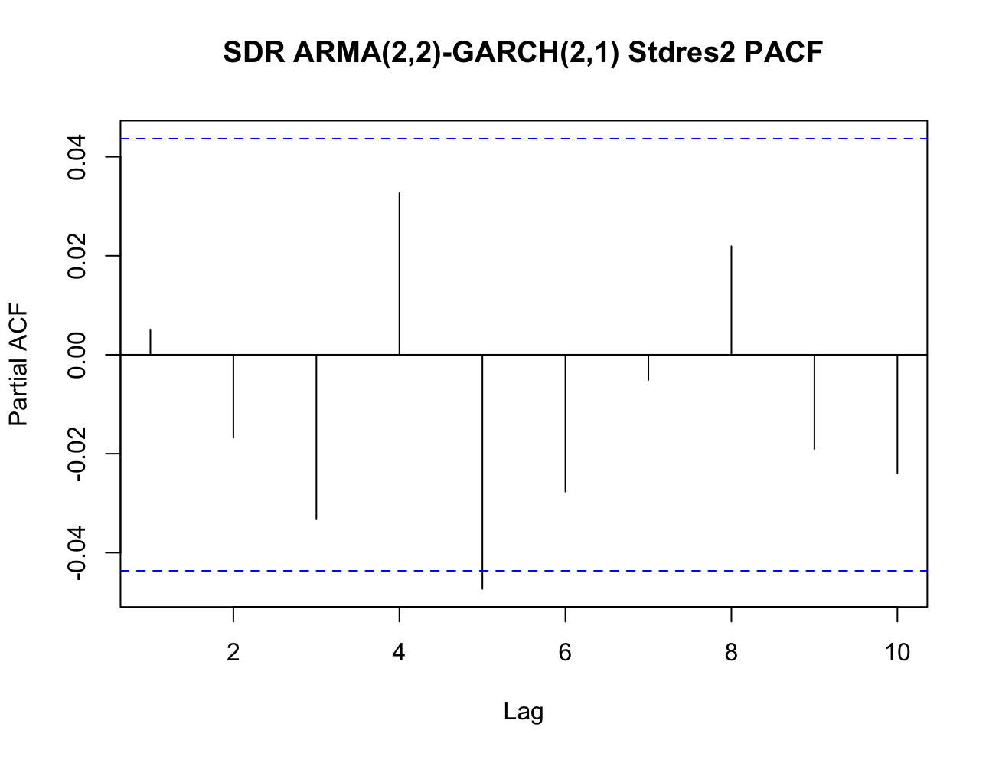
Standardised square residuals ACF tests for ARMA-GARCH models

The standardised squared residuals appear to have relatively no autocorrelation with ACF and PACF within p-value of 0.05 for all four CNY, USD, TWI and SDR. This meant that the GARCH model is correctly specified, the standardised residual should be independent and identically distributed, indicating adequate ARMA-GARCH models.
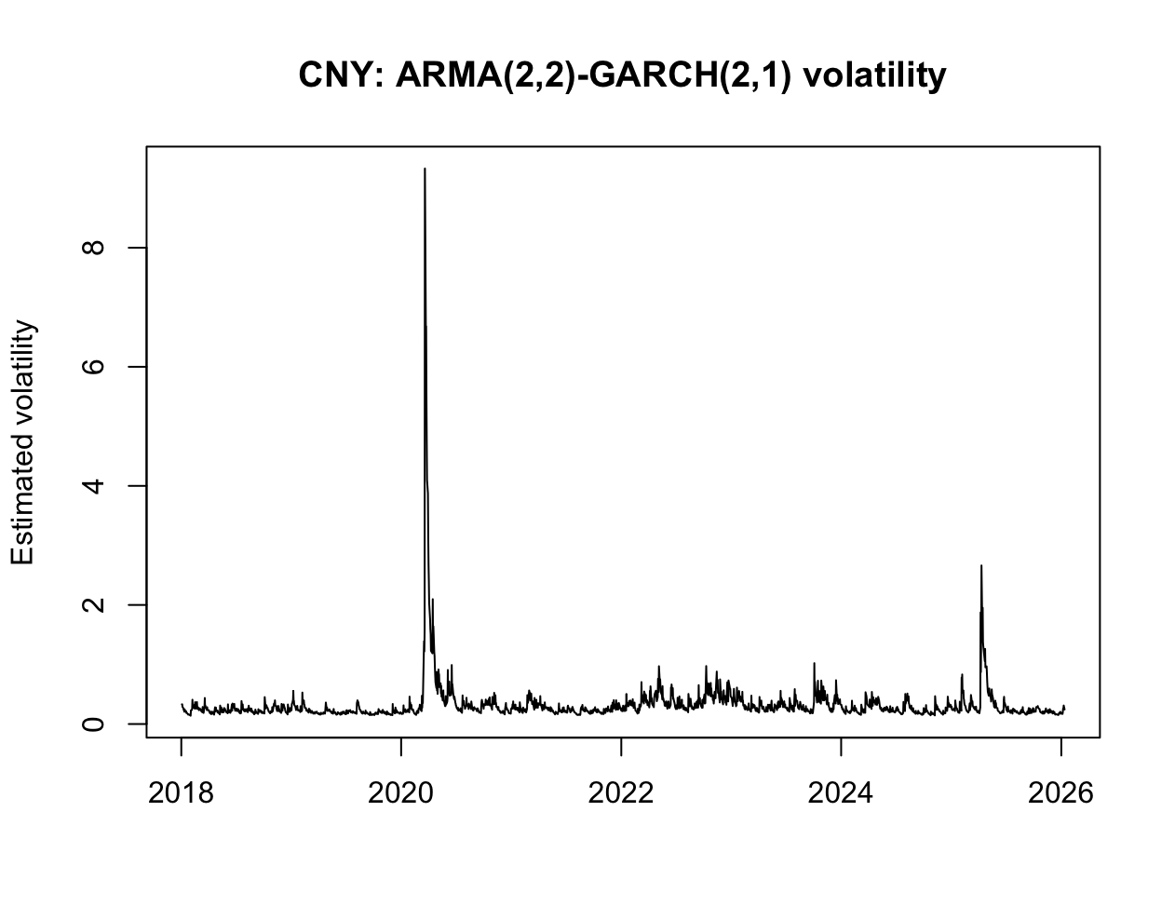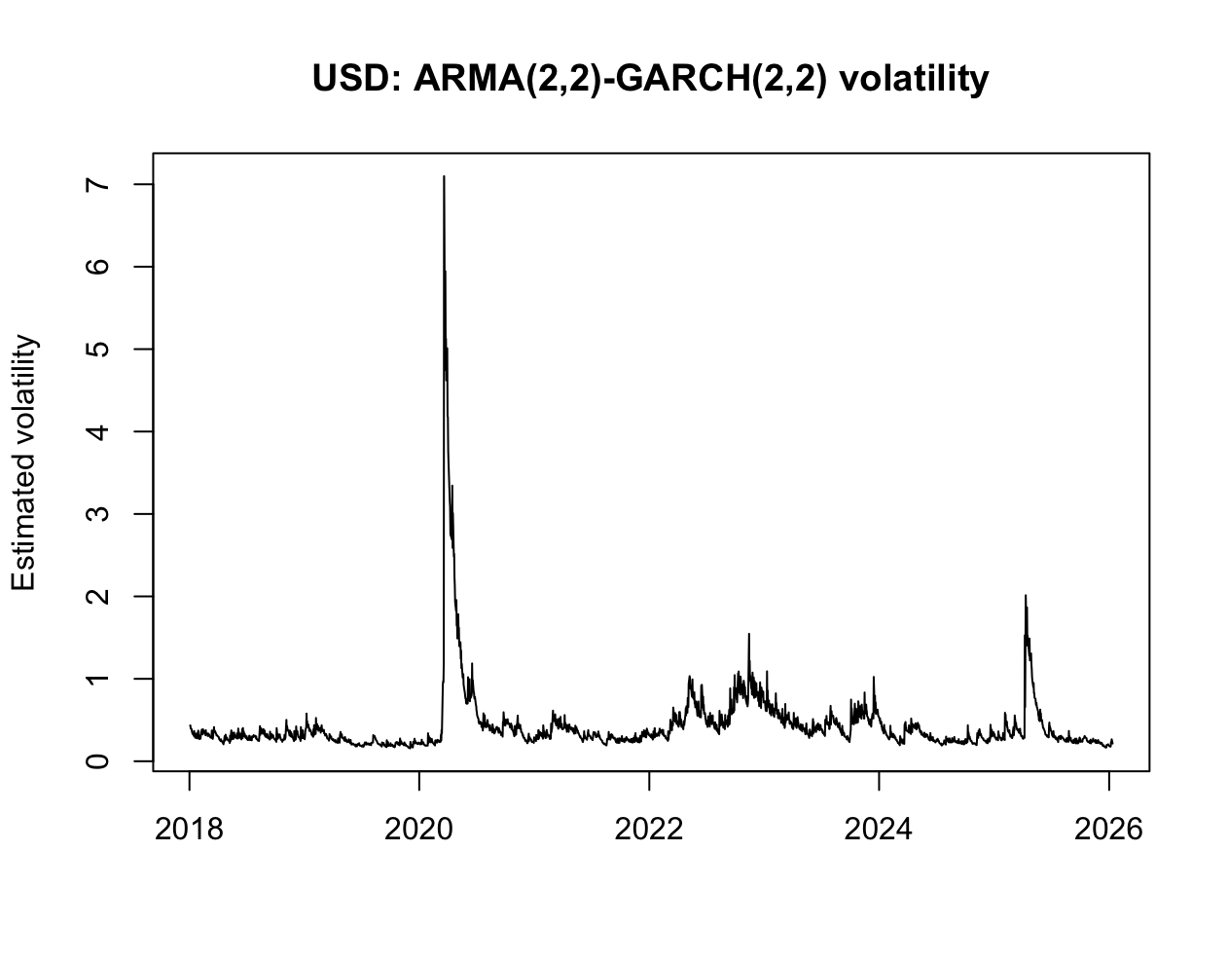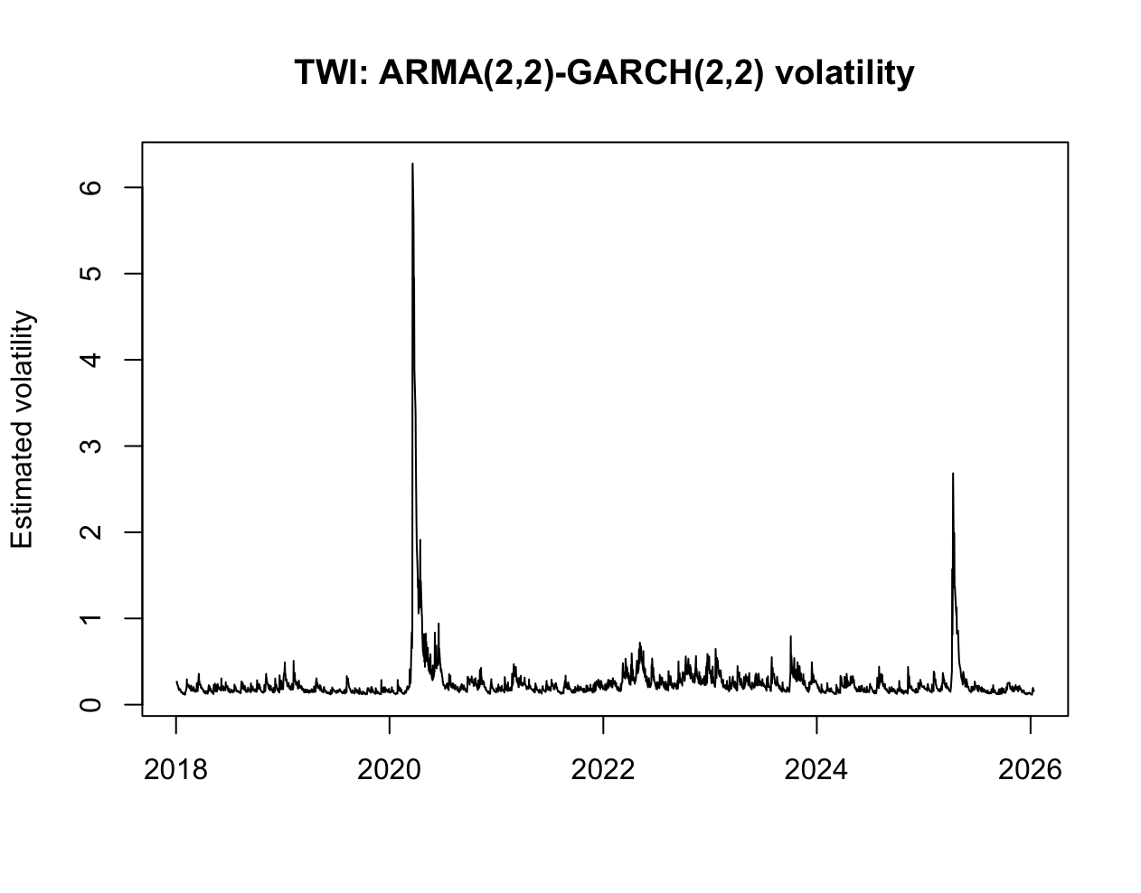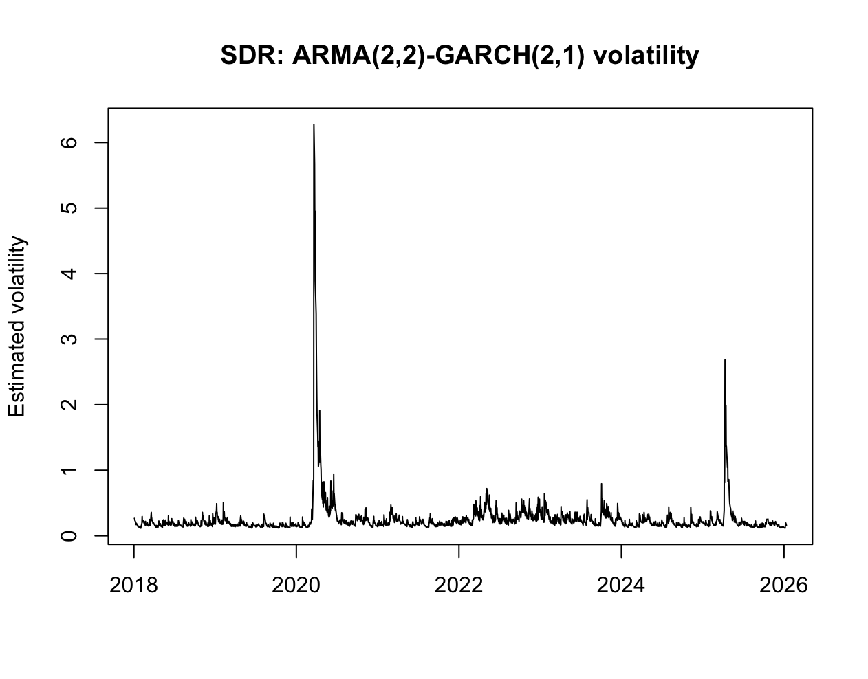
The estimated final ARMA-GARCH models (Variance)

Question 7:
The unconditional variance (e.g. GARCH (1,1)):
$$σ_{model}^{2}​=\frac{α_{0}}{1-α_{1}​-β_{1}}​​​$$
Because if the estimated variance process is not stable, the unconditional variance does not exist as a finite number. In the course notes, stability for GARCH (1,1) requires $α_{1}+β_{1}<1$. If that fails, the long-run variance does not converge to a finite value.

Series | α₀ (omega) | α₁ | α₂ | β₁ | β₂ | α+β | Uncond. Variance
CNY | 0.03066 | 0.15923 | – | 0.30803 | 0.43266 | 0.8999 | 0.30632
USD | 0.01162 | 0.09764 | 0.00180 | 0.26389 | 0.60918 | 0.97188 | 0.41322
TWI | 0.02322 | 0.15745 | 2.6e-10 | 0.22398 | 0.52154 | 0.9030 | 0.23930
SDR | 0.01565 | 0.13289 | – | 0.25225 | 0.57983 | 0.96497 | 0.44675
Coefficient results from the estimated ARMA-GARCH models

Comparing the results to sample variance of the first difference series, we discover that the unconditional variances are all very similar – this is expected given both measure the long run volatility of returns. However, the ARMA-GARCH estimates are systematically lower as it accounts of heteroskedasticity – separating persistent variance from short-term shocks. In contrast, sample variance treats observations equally which may be inflated by periods of high volatility.

Question 8
To find the probability that returns are less than 0.01% we use ugarchboot to forecast both the mean return and the volatility to find $P\left(r_{t}<0.01\%\right)$ given $r_{t}\sim N\left(μ_{t},σ_{t}^{2}\right)$, for 13/07 and 14/07 ($t=1, 2$)

EX rate | Day | Mean return ($μ$) | Variance ($σ^{2}$ ) | Probability | E[P]
CNY | 13/01/2026 | $$-0.0159$$ | $$({0.491}^{2} = 0.2411)$$ | $$52.10\%$$
CNY | 14/01/2026 | $$-0.0156$$ | $$({0.499}^{2} = 0.2490)$$ | $$52.04\%$$ | 52.07%
USD | 13/01/2026 | $$-0.0381$$ | $$({0.480}^{2} = 0.2304)$$ | $$53.99\%$$
USD | 14/01/2026 | $$-0.0375$$ | $$({0.475}^{2} = 0.2256)$$ | $$53.98\%$$ | 53.99%
TWI | 13/01/2026 | $$-0.0543$$ | $$({0.401}^{2} = 0.1608)$$ | $$56.38\%$$
TWI | 14/01/2026 | $$-0.00136$$ | $$({0.408}^{2} = 0.1665)$$ | $$51.11\%$$ | 53.75%
SDR | 13/01/2026 | $$-0.0523$$ | $$({0.472}^{2} = 0.2228)$$ | $$55.24\%$$
SDR | 14/01/2026 | $$-0.0398$$ | $$({0.475}^{2} = 0.2256)$$ | $$54.17\%$$ | 54.71%
Probability results between 13/01/2026 and 14/01/2026

The estimated return distribution across four exchange rates indicate that all currencies indicate negative mean returns. This implies that none provide positive expected payoff above 0.01% over the sample period as expected average probability range from 52%-55%. As a result, investments should be driven by risk minimisation rather than return maximisation where volatility, measured by variance of returns, becomes the determinant in attractiveness. TWI consistently exhibits the lowest variance, reflecting greater stability given its construction as a diversified basket of currencies. This is supported by a relatively neutral probability of downside returns compared to the others. In contrast, USD and SDR display higher volatility and likelihood of negative returns, making them less desirable from a risk-adjusted perspective.

Appendix
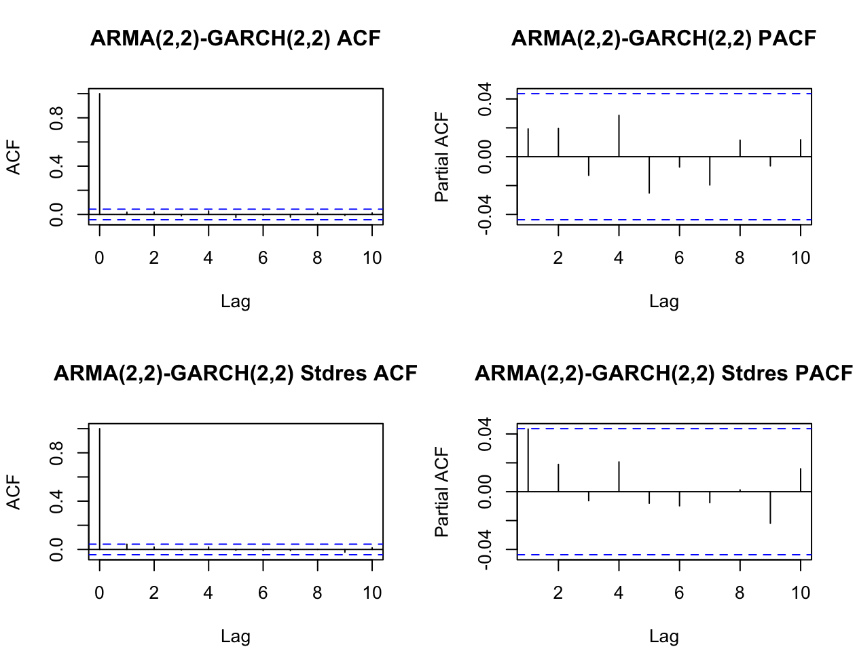
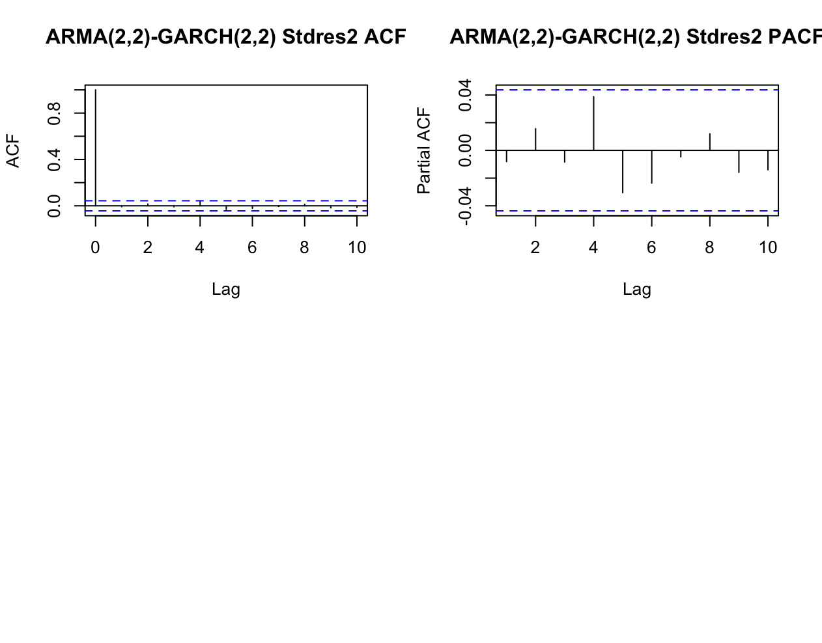
TWI:
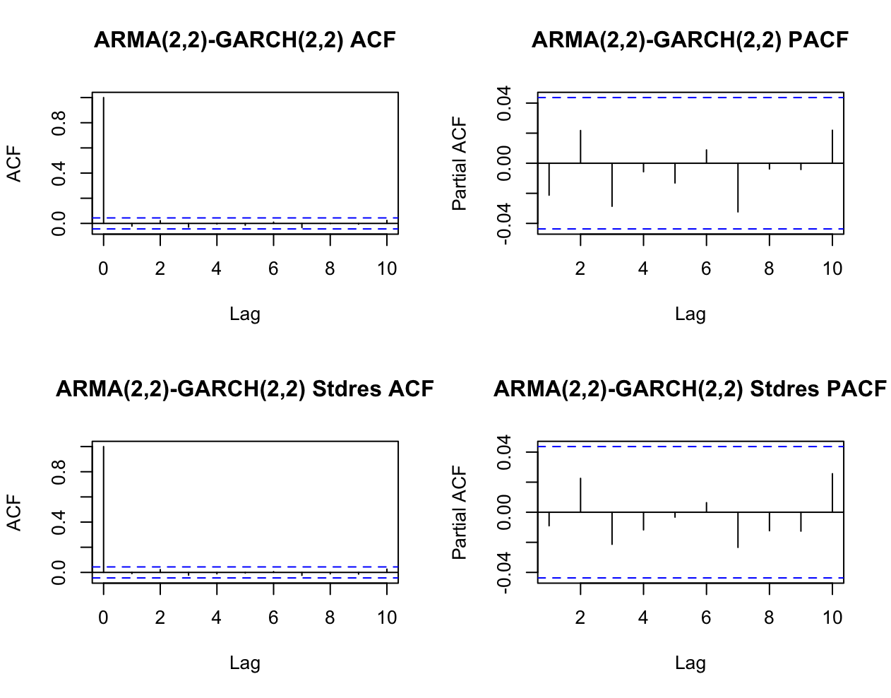
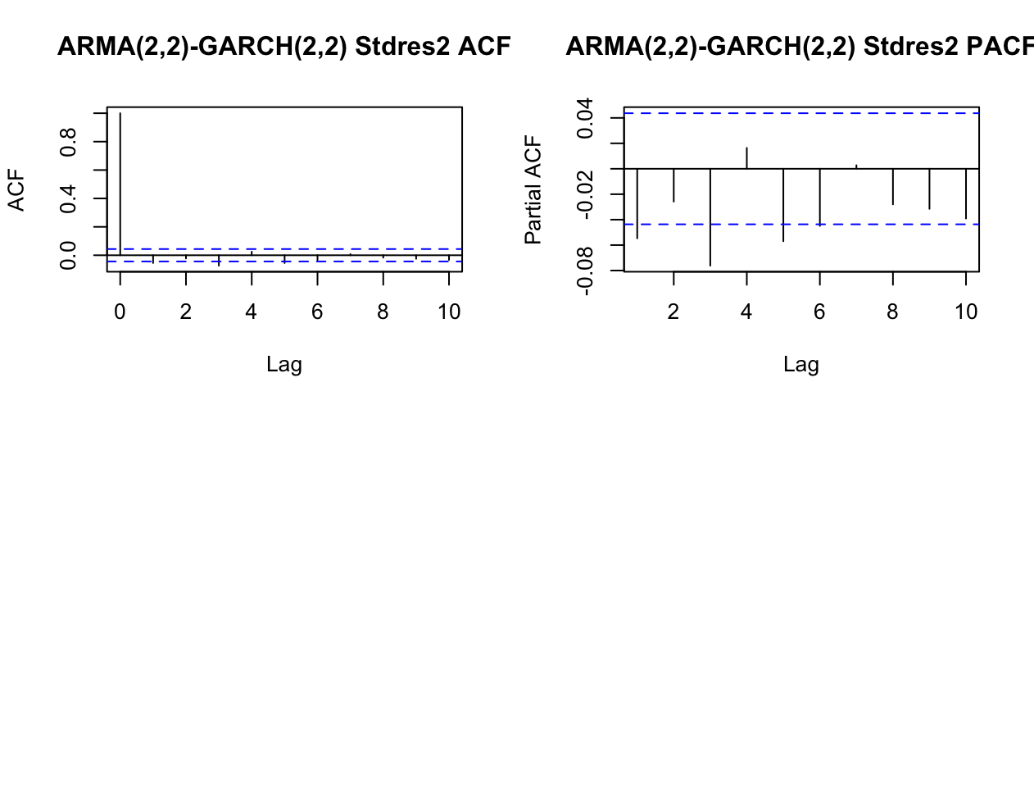

Sdr:
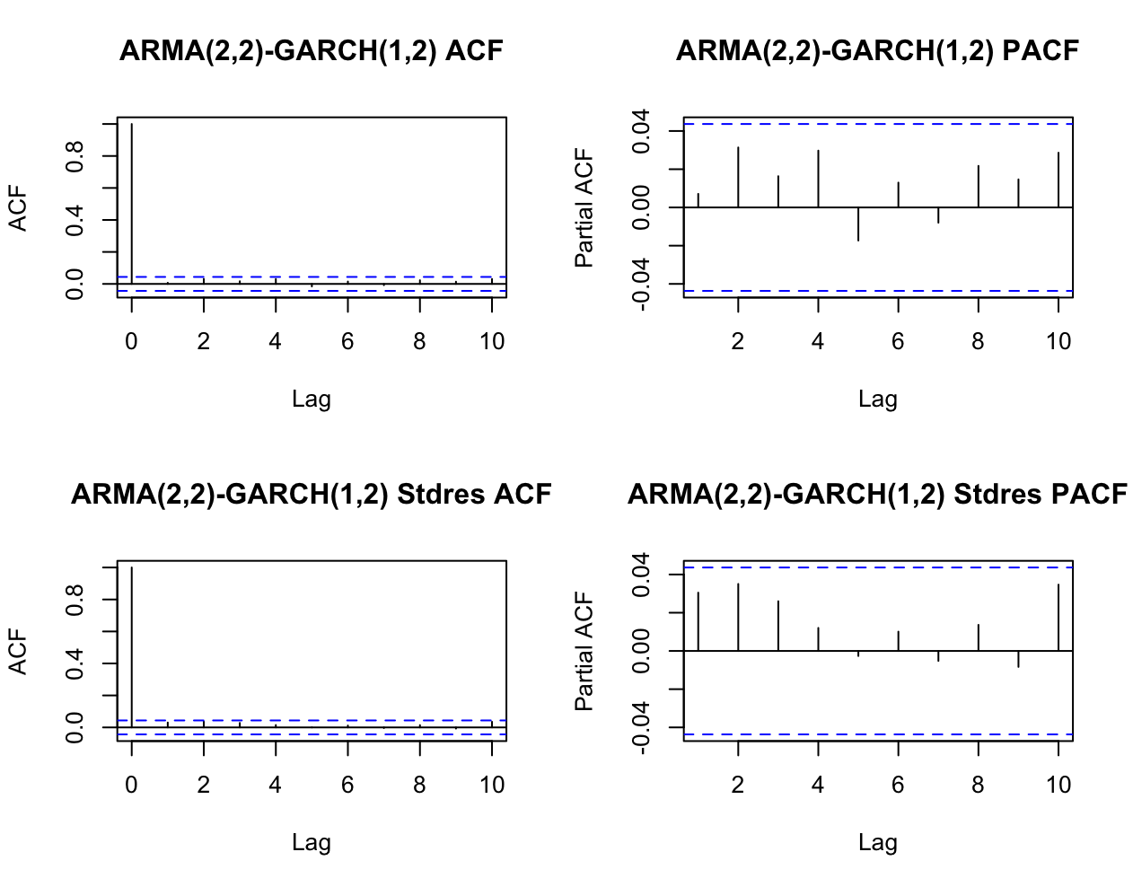
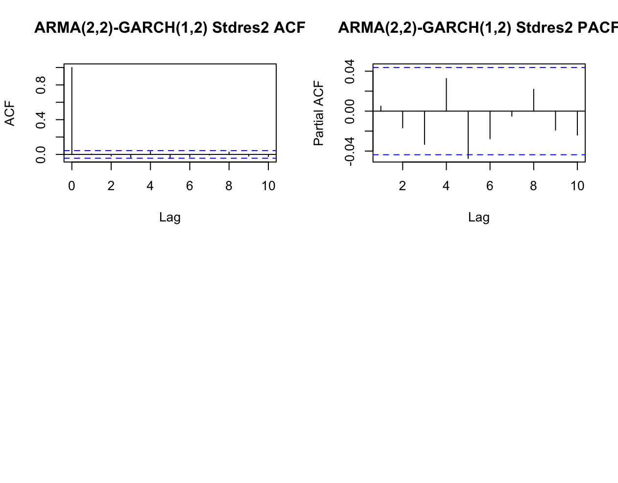
CNY:
$r_{1}\sim N\left(-0.0159,{0.491}^{2}\right)$, $r_{2}\sim N\left(-0.0156,{0.499}^{2}\right)$,
$P\left(r_{1}<0.01\%\right)=52.10\%,$, $P\left(r_{2}<0.01\%\right)=52.04\%$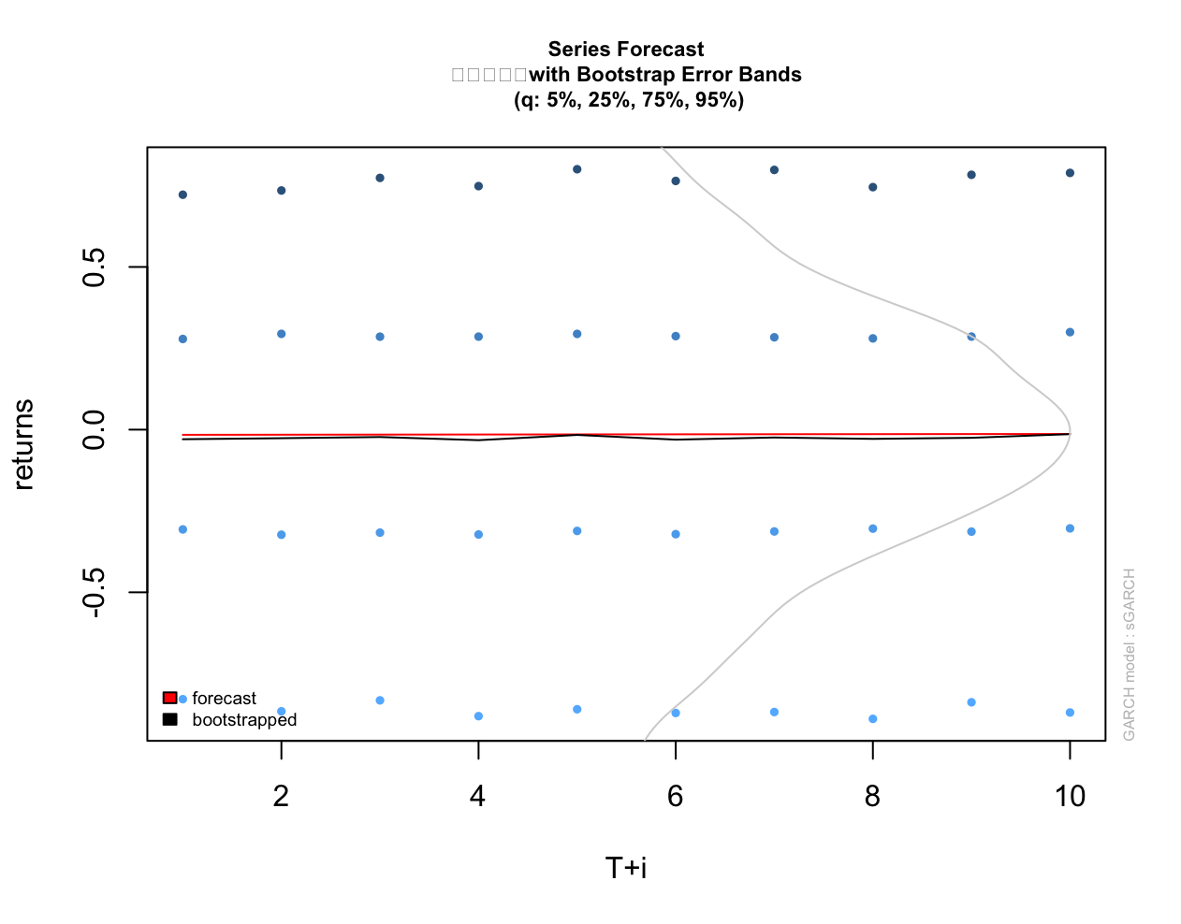 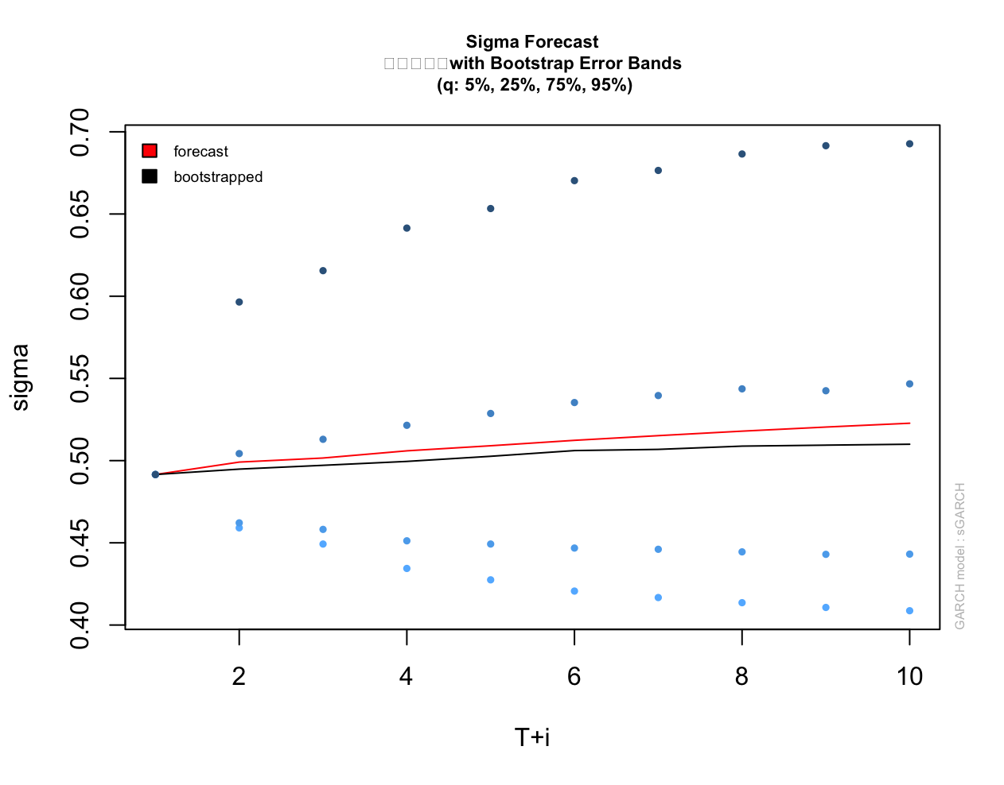
USD:
$r_{1}\sim N\left(-0.0381,{0.480}^{2}\right)$, $r_{2}\sim N\left(-0.0375,{0.475}^{2}\right)$,
$P\left(r_{1}<0.01\%\right)=53.99\%,$, $P\left(r_{2}<0.01\%\right)=53.98\%,$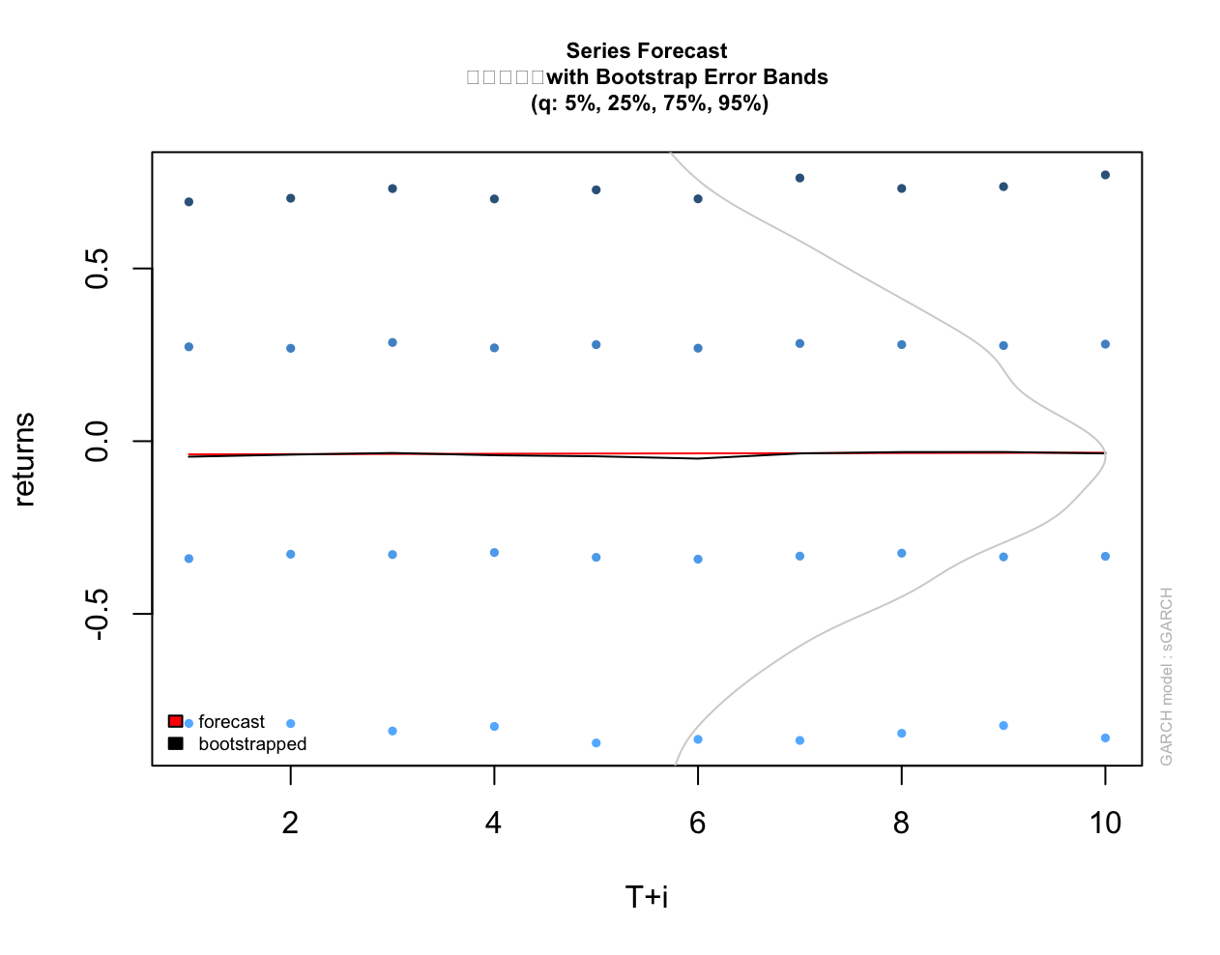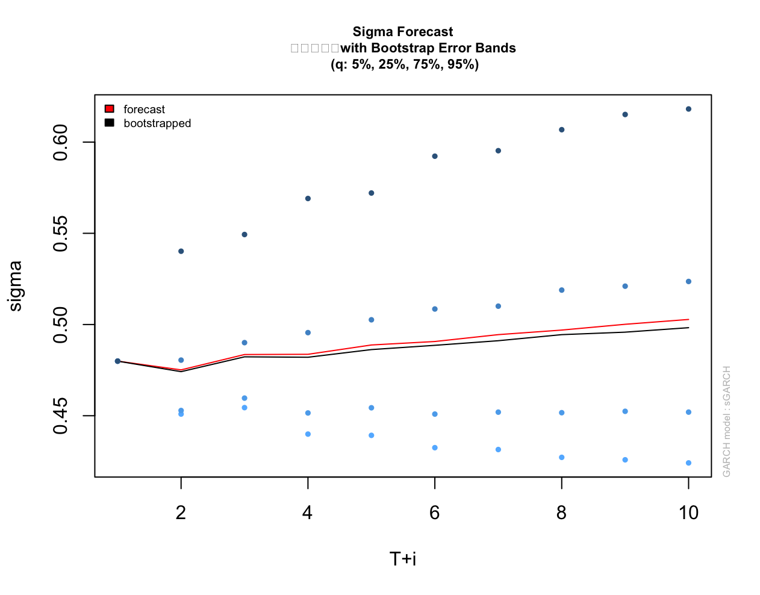
TWI:
$r_{1}\sim N\left(-0.0543,{0.401}^{2}\right)$, $r_{2}\sim N\left(-0.00136,{0.408}^{2}\right)$,
$P\left(r_{1}<0.01\%\right)=56.38\%,$, $P\left(r_{2}<0.01\%\right)=51.11\%$
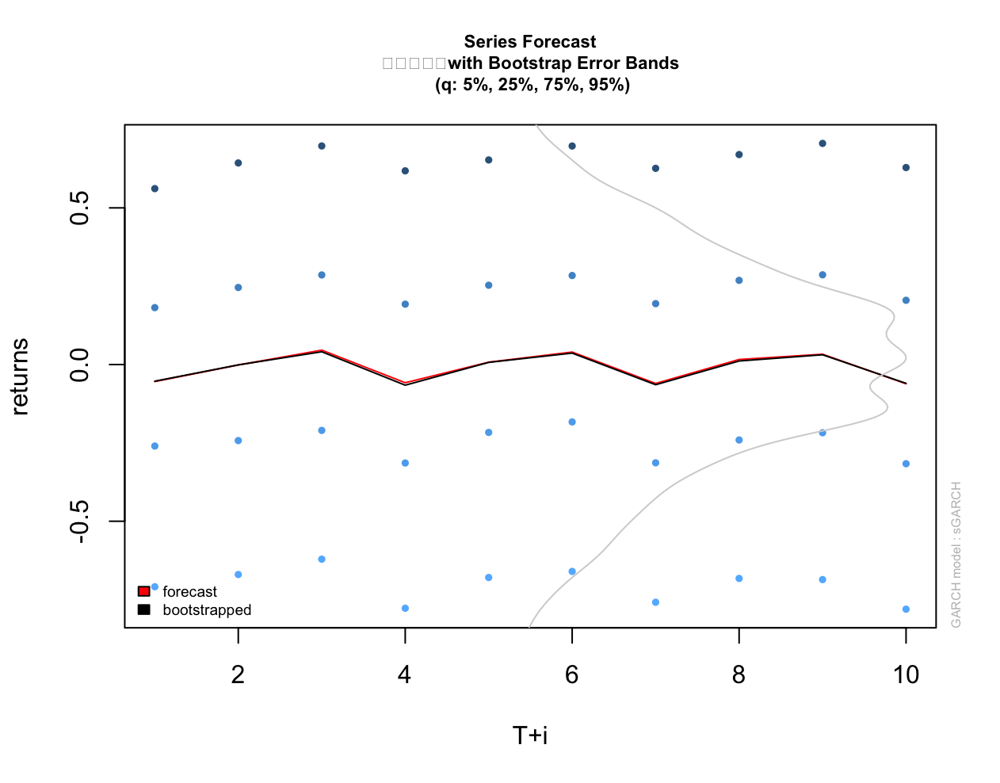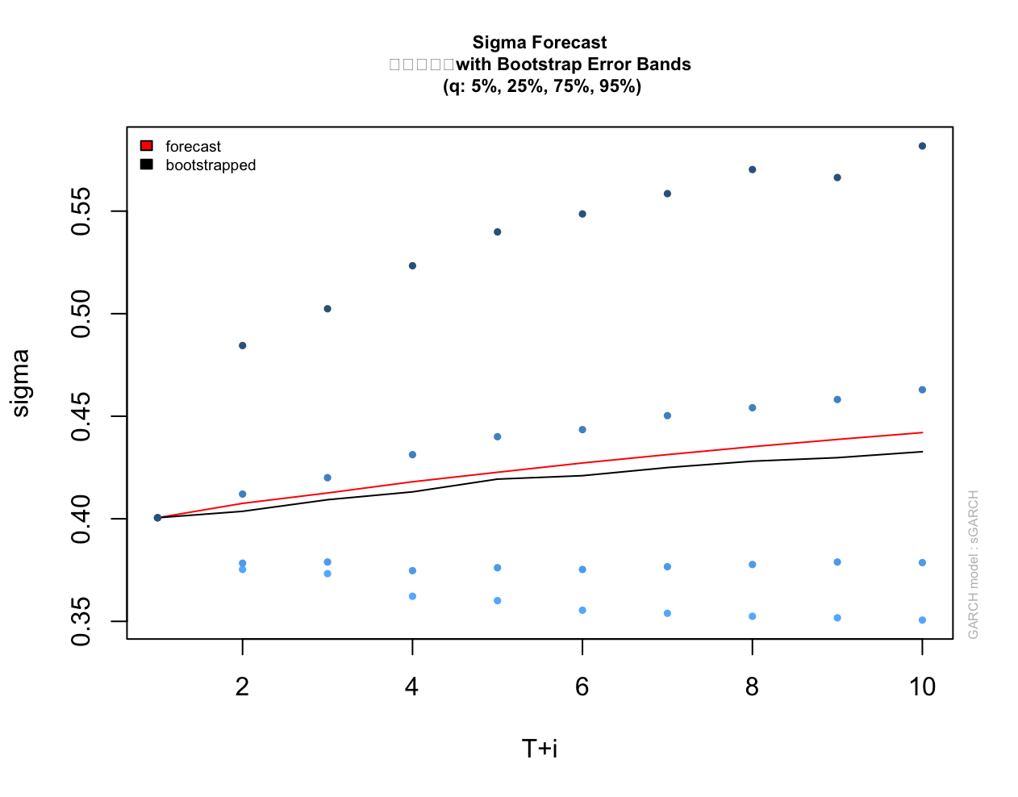
SDR:
$r_{1}\sim N\left(-0.0523,{0.472}^{2}\right)$, $r_{2}\sim N\left(-0.0398,{0.475}^{2}\right)$,
$P\left(r_{1}<0.01\%\right)=55.24\%,$, $P\left(r_{2}<0.01\%\right)=54.17\%$
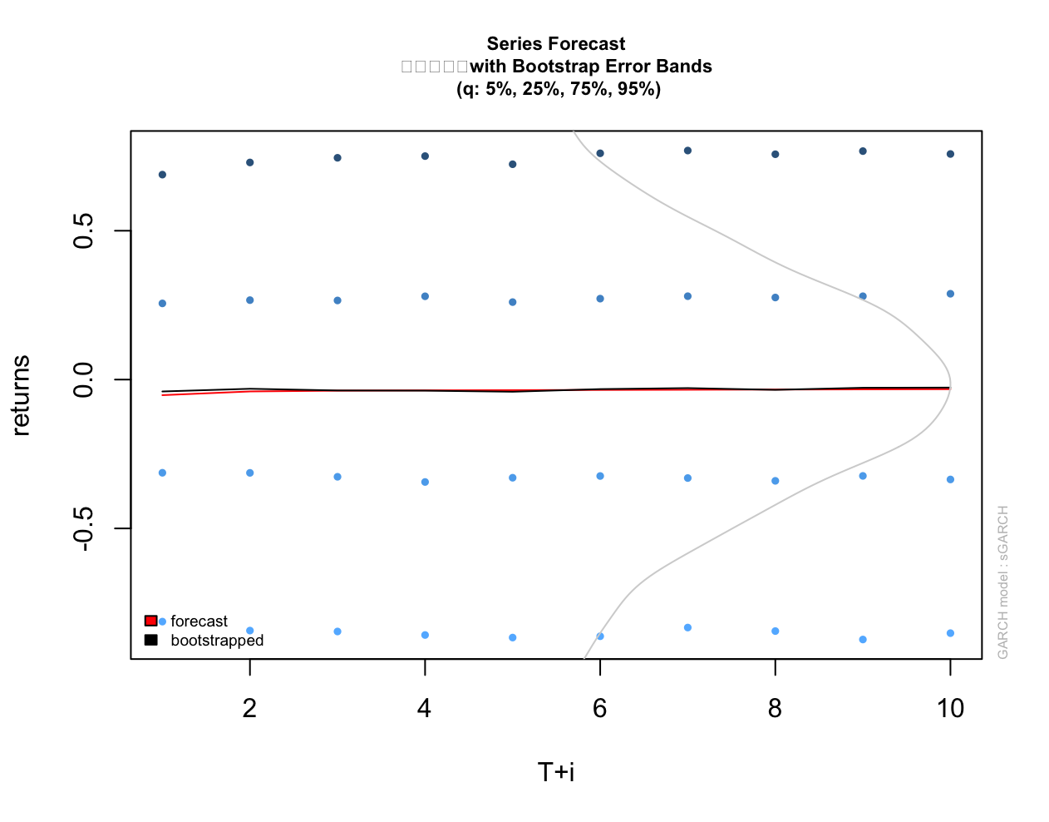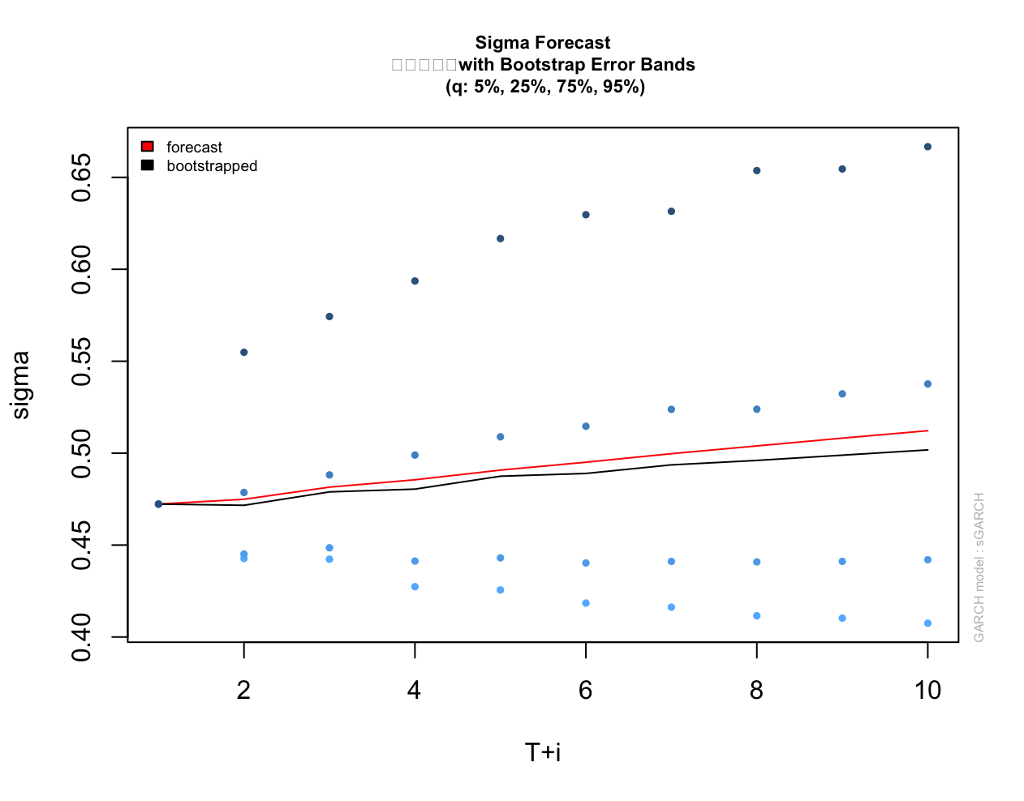

SUMMARY

If It has trend, constant, but d=0 it’s trend stationary, meaning its it is staiotnary if you do not consider the trend, so it is not random walk

If trend or constant, but d=1, you need difference stationary, it becomes stochastic, driven by accumulated shocks instead if there appears to be a trend

No trend, d=0, full stationary and stochastic process. Mean is constant

No trend, d=1, pure stochastic, random walk just drift.

